Title: Peel and tensile test investigation of aluminium 1050 foil parts made with a new additive manufacturing process
Abstract
In this paper, peel and tensile tests were carried out on specimens that were made using a new additive manufacturing process referred to as Composite Metal Foil Manufacturing. A detailed explanation of the process along with a conceptual model and flow chart of operation has been presented. Three peel tests under different conditions were performed to assess the effectiveness and flexibility of this new process. The first test uses 100 micron thick Al 99.5 foils at three different peeling rates. The second is performed on the foils at one peeling rate following corrosion testing to assess the effect of corrosion on the peel strength. The third test was carried out on composite specimens of Al 99.5 and 99.99% pure copper foils of 100 micron thickness. The resulting peel strength in each test gives an indication of the integrity of the bond formed by the new process. The results show that the peel strength is not affected by the rate of peeling. The specimens did not face the problem of galvanic corrosion of the foil and bond interface as any corrosion in this area would seriously undermine the peel strength. The composites also exhibited results consistent to previous tests proving that under all conditions the performance of the new process remains equally effective. The tensile test demonstrate that the part produced by the proposed process is 8% stronger than a part machined out of an aluminium block. The results prove that not only the process is capable of producing consistent results but also stronger parts when compared to traditional machining methods.
Keywords: additive manufacturing; brazing; corrosion; laminated object manufacturing; metal foils; peel test

Introduction
Additive manufacturing (AM) is an umbrella term referred to a group of technologies that produce three dimensional objects from computer aided design (CAD) data by laying down successive layers of material. A large number of additive manufacturing processes are commercially available. The main differences among the processes are the way layers are deposited to create parts and the materials that are used. These technologies are considered to be the future of manufacturing and it is largely due to the production of parts from a range of materials including plastics, ceramics, metals etc. Metal prototyping is highly valued in the technological market because metal parts made this way would provide more realistic indication of how the part would behave in a particular situation. There are a few additive manufacturing processes capable of producing metal parts, namely Direct Metal Laser Sintering (DMLS), Electron Beam Melting (EBM), Selective Laser Melting (SLM) and Selective Laser Sintering (SLS). All these processes are well known and are widely documented in literature [1-10]. Their advantages and disadvantages go hand in hand as they more or less works as allies rather than competitors. There are, however, a couple of processes that have made an impact owing to their innovative design, namely Metal Foil Laminated Object Manufacturing and Ultrasonic Consolidation (UC). The former method builds metal parts using metal foils and it combines Laminated Object Manufacturing (LOM) with diffusion welding but the setup is expensive and poses operating issues [11]. It cannot work with thicknesses less than 0.5mm as anything less than that results in staircase effect. The process also requires the generation of contours that require a sufficient self-stiffness of the sheets and anything less than 0.5mm results in failure of the contour generation. The surface quality is not good and the products require post processing such as milling, build-up welding or shot peening where necessary [12]. The latter process is rather an interesting prospect as it has shown great promise in working with difficult metals like aluminium and stainless steel. It combines ultrasonic seam welding of metals and layered manufacturing techniques to build up a solid freeform object [13]. The process starts with attaching a base plate to the machine anvil and then metal foil is placed on the base plate. A sonotrode connected to a transducer is used to apply pressure and ultrasonic oscillations to the foil to bond it to the base plate. The process is repeated until the required height is achieved and then a CNC (Computer Numerical Control) mill is used to trim the excess foil from the component and achieve the required geometry. Another finishing mill is brought into action to create the required tolerance and surface finish. After the trimming and finishing, the finished part is removed from the anvil [14-16]. The biggest challenge of this process is optimization of the process for bond density and plastic flow to have a better contact between the foils [17]. The sonotrode contact with the metal surface (performed under pressure and with an oscillatory motion at ultrasonic frequency), creates a highly deformed surface that could lead to levels of porosity between the foil layers of an Ultrasonically Consolidated component. Inter-laminar porosity in UC could also result in reduced mechanical performance when compared to monolithic structures of the same material [18, 19].
The paper presents a novel additive manufacturing process that solves the majority of the mentioned problems and also offers simplicity to its end users. The proposed process is named as Composite Metal Foil Manufacturing (CMFM) and is a combination of LOM and brazing technologies. These two processes have been around for decades but never integrated together for the production of metal parts. CMFM combines the simplicity of LOM with the flexibility of brazing that makes it a very efficient process. Specimens for peel tests were produced using this process from Aluminium 99.5 foil (1050 grade with a H14 ½ hard temper) and copper foils (99.99% pure) of 100 micron thickness and tested according to the British and International Standards.
The product development has two stages - the principles of LOM for cutting and stacking of sheet metal and brazing to join the foils and make a part. The term brazing is preferred to soldering as the joining temperatures were predominantly above 450ºC. Copper, silver, and gold have good brazeability; iron, mild steel and nickel have reasonable brazeability. Because of their thin, strong oxide films, stainless steel and aluminium are among the difficult ones to braze. It is worth mentioning that previously, copper testing was carried out to establish the effectiveness of the process [20].
Aluminium is one of the hardest metals to braze and various aluminium alloys have different brazeability: the 1xxx, 2xxx, 3xxx, 4xxx, and 7xxx series are easier to braze than the 6xxx series alloys. Magnesium content in the 5xxx series alloys makes them the most difficult to braze. This is because, in addition to the oxide layer of aluminium, the oxide layer of magnesium needs to be removed to perform the brazing process. Additionally, on contact with air, a magnesium oxide layer is formed, thus there are two layers to remove when joining aluminium alloys containing magnesium [21]. As the removal of the oxide layer is the key to the brazing process, a special flux is used when brazing aluminium alloys. Although traditional tin/lead solders can be used to braze aluminium, the large difference in the electro potentials of the aluminium substrate and the tin/lead solder present a galvanic couple that can lead to accelerated corrosion. This problem can be avoided with the use of either tin/zinc eutectic solder or higher temperature zinc/aluminium solder as the bonding alloys for brazing aluminium. The removal of copper oxide is relatively easy and can be done with ‘normal’ soldering methods using mild fluxes whereas aluminium oxide requires stronger fluxes that can go up to temperatures of 550 °C [22, 23]. Other methods such as mechanical rubbing, ultrasonic, thermal spray, pre-coating etc., can also be employed to remove the oxide layer if no flux is used. Tin/zinc soft solders are more commonly used with normal fluxes since their melting point is under 330°C and the zinc portion helps in preventing galvanic corrosion. The solders based on zinc are termed as hard solders because they use fluxes that offer higher melting temperatures to activate. Zinc is an element made up of hard, sharp-edged crystals that aid in abrading (scrubbing) through the tough aluminium oxide layer, thus permitting the metallurgical reaction between the filler and base metals to occur. This research deals with very thin aluminium foils so special attention was given while brazing as there is a danger of pitting that will leave the specimens useless for testing. For these reasons, aluminium zinc brazing paste with non-corrosive flux was chosen to make the peel test specimens of Al 99.5.
In general, aluminium has good corrosion resistance because of its oxide layer. However, in a peel specimen, there is a bond present between the aluminium foils and any corrosion at the bond/foil interface could cause serious issues. The most common types of aluminium corrosion are galvanic corrosion and pitting. Galvanic corrosion of aluminium occurs when there is contact with a more noble metal (or other electron conductor with a higher chemical potential than aluminium, e.g. graphite) and at the same time, there is an electrolyte (with good conductivity) between the metals. Therefore, 80% zinc and 20% aluminium brazing paste has been carefully chosen for this research, as this alloy has a similar electrode potential to aluminium and will therefore minimise, if not eliminate, galvanic corrosion. For aluminium, pitting is by far the most common type of corrosion. It occurs only in the presence of an electrolyte (either water or moisture) containing dissolved salts, usually chlorides. The corrosion generally shows itself as extremely small collection of pits that, in the open air, reach a penetration of a minor fraction of the metal’s thickness. Penetration may be greater in water and soil. As the products of corrosion often cover the points of attack, visible pits are rarely evident on aluminium surfaces. Microscopic inspection is the best way to observe pitting of aluminium.
Peel testing is one way to characterize peel strength between two bonded surfaces. This peel strength may be referred to as the “stickiness” of a material as it is a measure of the specimen’s resistance to separation from one another after a bond has been made. This measured value may then be used to determine if the bond is strong enough for the application and whether a different bonding process is needed. Peel strength can change as the peel angle changes so careful consideration should be given while testing the specimens [24]. These peel tests are usually conducted at a constant rate but at various angles. The most common types of peel tests for the measuring of peel strength are the T-peel, 90 degree peel, and the 180 degree peel. The T-peel test is a type of tensile test performed upon two flexible substrates that have been bonded together and placed into peel test grips such that one substrate sticks up and the other sticks down while the bonded area sticks out horizontally so that the entire setup forms a “T” shape [25].
Each metal has its own unique set of properties. When a metal product is made, different metals are used in such a way that every material can contribute to the structural integrity of the product. This is not an easy task when dissimilar metals are joined because now there are two unique sets of properties joined together to form something that is different from both parent metals. A number of industries rely on multiple material metal products to provide cheaper, lighter, and stronger alternatives. It is because of this ever increasing demand of innovation that a composite of aluminium and copper make a good substitute to traditional products. Copper has a number of prominent qualities that make it a very good candidate for industrial use including corrosion resistance, high thermal and electrical conductivity, strength, excellent solderability etc. Aluminium, as previously mentioned, is one of the most difficult metals for brazing but has a number of important properties including low weight, high strength, superior malleability, easy machining, excellent corrosion resistance and good thermal and electrical conductivity. Peel testing of a copper and aluminium specimen is an exciting prospect as it will shed more light into the bond characteristics produced by the proposed process.
This paper reports on peel tests performed under three different conditions. The first deals with peel testing of Al 99.5 specimens at various cross-head speeds. The second test is done with similar aluminium specimens at 10mm/min after they went through galvanic corrosion testing to assess the effect of corrosion on the peel strength. The third test is conducted at 10mm/min on composites produced by Al 99.5 and copper foils. The peel strength of each set of experiments was calculated and the results compared to establish the consistency and effectiveness of CMFM. In addition to this, the test results were compared to a similar work done by Kong, Soar and Dickens [26].

Composite Metal Foil Manufacturing Process Design

2.1. Process Details
The main components of the process are a feed mechanism that advances a metal sheet over a build platform, a laser to cut the outline of the part in each sheet layer, a dispenser that dispenses brazing paste on the metal sheets, a roller that smooth the paste into a uniform layer, two laser sensors for measuring the thickness of the part at all times, heated plates to apply pressure and heat to bond the sheets together to produce the final product. Fig. 1 shows the conceptual model of the machine based on the principle of composite metal foil manufacturing.
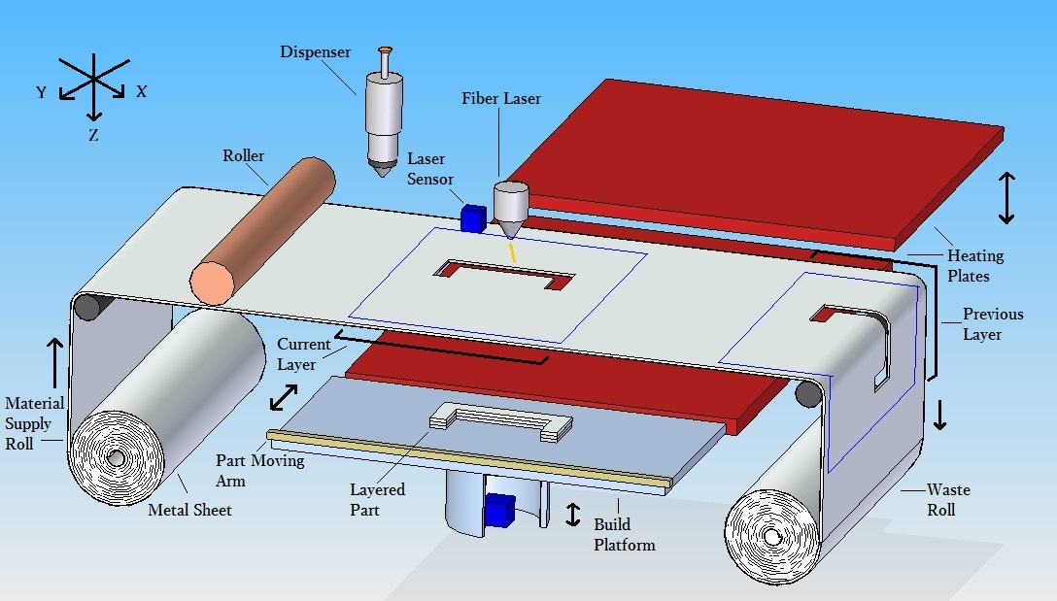
Figure 1: Composite metal foil manufacturing process
The proposed process starts with the 3D CAD model of the part being transferred, by the use of 3D Slicer software, to a set of layer data according to the geometry of the part. This software creates layer data that is fed into the main program which then controls the flow of sheets from the material supply roll. The sheet metal comes in through the feed mechanism and the laser cuts the outline of the part in the first layer. A 200W fibre laser from MIYACHI is selected for this process as it has the capability of cutting metal sheets as thin as 50 microns with high dimensional accuracy. Another advantage of using fibre laser is that it offers minimal thermal input, with fine control over how hot the work area gets. This is important because small parts heat up quickly and might otherwise overheat or deform. Fibre lasers are highly focusable to about 15 microns, which is about 1/6th of the width of a strand of human hair. This makes it feasible to remove the minimum amount of material to make the cut, resulting in extremely high precision and accuracy. The laser operates automatically on receiving the layer data from the CAD model. Fig. 2 shows a flow chart of the composite metal foil manufacturing process.
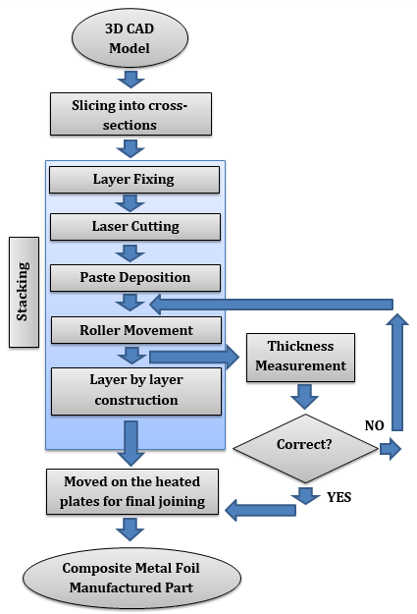
Figure 2: Flow chart of CMFM
The process is slightly different when it comes to fixing the first layer. After the outline cutting of the first layer, the dispenser dispenses solder paste on it according to the defined geometry and the platform stays at its original position. The feed mechanism moves upward and moves the remaining of the sheet to the waste take-up roll. Another sheet is then advanced on top of the previously deposited layer. It is placed on top of the first layer by the feed mechanism that is capable of moving up and down just like the build platform. Before the laser cutting, a roller rolls on the surface of the sheet to make a uniform layer of the paste between the first and second layer. Model 710 Automatic Applicator from Fusion Automation Inc. was chosen based on its ability to dispense precise and minute quantities of paste without any waste. This compact unit features adjustable time and pressure controls to provide paste deposit sizes ranging from small dots to continuous stripes of any length. Each paste deposit is precisely measured, ensuring controlled filler metal costs without waste. The amount and time of dispensing is based on the geometric features of the layers.
The heat produced during the cutting process melts the solder paste at the edges that keeps the two foils in perfect alignment. The platform is then moved down according to the thickness of the foils and the solder layer between them. The thickness is measured by two laser sensors that send the information to the system so that no error occurs in lowering the platform. The next sheet then comes in and the platform moves upward. The laser cuts the outline which again melts the paste at the edges. The process goes on until all the sheets have been cut and deposited with solder paste. If the extra material is allowed to stay in place then it would be an extremely difficult post processing operation to remove the unwanted metal from the desired part. The measurement of thickness during the process is an important aspect as it ensures dimensional accuracy of the part being produced. The Microtrak™ 3 TGS system is designed specifically for thickness applications. The product can easily interface with PLCs and PCs, or can be used in a standalone configuration. Each module contains an integral LCD display and keypad for setting up and visual display of measurements. Basic input output is provided by discrete lines or a serial interface configured as Modbus® RTU over RS-485 or RS-232. The two sensors are mounted on either sides of the platform to ensure accuracy in thickness measurement. The sensors have a measuring accuracy of ±1-1270mm and a measuring speed of 9400Hz.
After the cutting, dispensing and stacking has been done, a stacked structure of solder-paste coated layers is left behind. The structure is stable enough to be moved and so an arm moves the structure onto the heated plate. It is then heated from top and bottom by a heated plate that applies pressure and heat to produce the product. It is important to describe the brazing paste being utilized as it is majorly responsible for the joining operation. The paste has a very high metal content consisting of 80% zinc, 20% aluminium by weight and a strong flux suspended in a binder. Just like any other brazing paste, its resistance to flow is not constant and it exhibits shear thinning. Most pastes are also thixotropic and their viscosity depends not just on the shear rate but also on the shear history of the paste. After stirring, the paste becomes less viscous but it is not the case with this paste. It was applied on the aluminium foils both after stirring and without stirring but the results were consistent showing that the paste is not thixotropic in nature. In addition to the dependence of viscosity on history, it also depends on temperature. Viscosity of a paste decreases at high temperatures owing to the change of state of one of the materials in the composition. The melting point of the solder paste in use ranges between 410 - 470 °C and it becomes liquid in this range. However, it should not be kept at these temperatures for longer periods of time as the flux would burn off and the paste would not be able to penetrate the tenacious oxide layer on the surface of the aluminium foil.
The heating plates are set to a temperature of 450 °C so as to allow for quick heating of the product. They apply heat and pressure-both are essential to ensure proper bonding and dimensional accuracy. The plates are of stainless steel and are fitted with FIREROD cartridge heaters from Watlow and can go up to a maximum of 750 °C. After heating the solder-coated layers for a certain amount of time depending upon its thickness, it is taken off and is now ready to be used.
The above explanation describes the process as a whole but the research was carried out by breaking down the process into independent steps that were performed to produce the testing specimens. The next section explains that breakdown and the practices utilized to prove the process.

EXPERIMENTAL SETUP
The process is complex and needed to be broken down into simple steps for practicality, thus an experimental setup was created to demonstrate the capability of the process. It was important to make sure that the process utilizes the minimum resources as one of the objectives is to make this process as cost effective as possible. As the process of brazing can be tricky for certain metals, it was necessary to make the process as adaptable as possible so that it can handle difficult metals.
Aluminium 99.5 foil (1050 grade with a H14 ½ hard temper) and copper foils (99.99% pure) of 100 micron thickness were used for the process and were cut according to the dimensions of the desired specimen. The foils were used as supplied with no surface treatment. Brazing paste was deposited and then the specimen was placed between two stainless steel plates fitted with nuts and bolts. At a time only one specimen was placed inside the plates and a uniform layer of paste was achieved by tightening the nuts with a torque wrench. The entire structure (paste-coated foils and plates) was placed inside a furnace. It was allowed to be heated for a set time and then taken out. After cooling the specimen was ready for testing as there is no post-processing involved.

Experimental Methodology

T-peel Test of Aluminium Specimens
The peel test was performed in accordance with BS EN ISO 11339:2010 [27], which was designed for the determination of the strength of adhesives on flexible-to-flexible bonded assemblies based on the maximum load specimens can withstand under peeling action. The Hounsfield Tinius Olsen Tensile Testing machine was used for carrying out the peel tests. The machine was operated at various speeds so that more insight could be sought regarding the strength of the bond. The specimens were 200mm long, 25mm wide and out of the 200mm length, 150mm was bonded with the brazing paste (Fig. 3). They were subjected to peeling speeds of 10mm/min, 50mm/min and 100mm/min. Al 99.5 foils were used for the production of peel specimens.
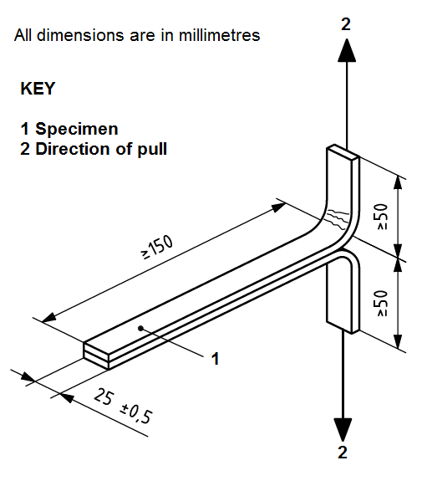
Figure 3: Dimensions of T-peel specimen

Corrosion Test of Aluminium Specimens
The corrosion test was performed in accordance with BS EN ISO 11130:2010 [28]. The peel specimens of Al 99.5 were immersed in a solution of 35 grams of sodium chloride dissolved in 1 lire of distilled water for 24 hours. Afterwards, they were dried for 24 hours and then tested on the Hounsfield Tinius Olsen Tensile Testing machine at a peeling rate of 10mm/min.

T-peel Test of Aluminium/Copper Specimens
Composite peel specimens of Al 99.5 and copper were produced according to BS EN ISO 11339:2010 and then tested on the Hounsfield Tinius Olsen Tensile Testing machine at a peeling rate of 10mm/min. Production and testing of composites is always very informative as it gives more insight and at the same time poses a number of issues. The ease with which the current process can produce these specimens shows its flexibility and the impact it could have on the technological industries.

Tensile Testing for Dog-bone Specimens
A dog-bone specimen was produced by following ISO 6892-1 [29]. The specimen (Composite Aluminium) produced by Composite Metal Foil Manufacturing (CMFM) was tested and then compared to the same shaped specimen machined out of an aluminium block. Both the specimens were 2.7 mm thick, 87.5mm long, 12.5mm wide and had a gauge length of 50mm (Fig. 4). The composite specimen was made up of 14 layers stacked on top of each other.
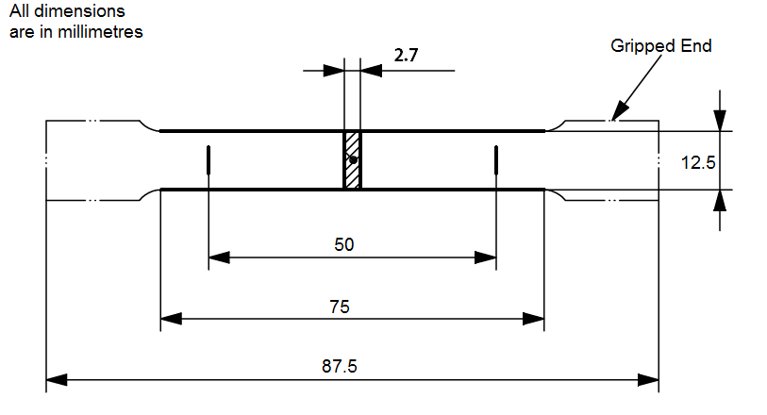Figure 4: Dimensions of the dog-bone specimen

Results & Discussion

Results from T-peel Test of Aluminium Specimens
The peel test was found to be effective in determining the bond effectiveness. The specimens had a bond thickness of 0.1 mm, therefore, the thickness of each specimen became 0.3 mm after it had been produced and was ready for testing. The results of a peel test are generally influenced by peel angle and peel rate. The peel angle was kept constant as shown in Fig. 5b whereby the peel rate was varied. Since the specimen was stiff enough to form a perfect ‘T’ shape after being loaded into the machine, the angle of separation was constant for all the tests.
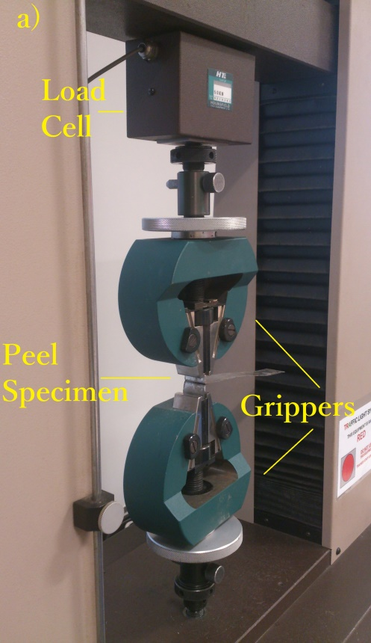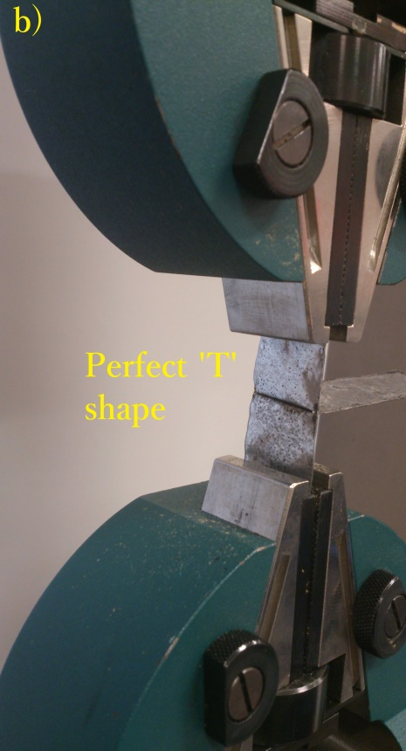
Figure 5: Peel testing a) Testing apparatus and b) Alignment of the specimen
From the specimens tested at three different peel rates, two categories of failure modes were observed and are shown in Fig. 6.
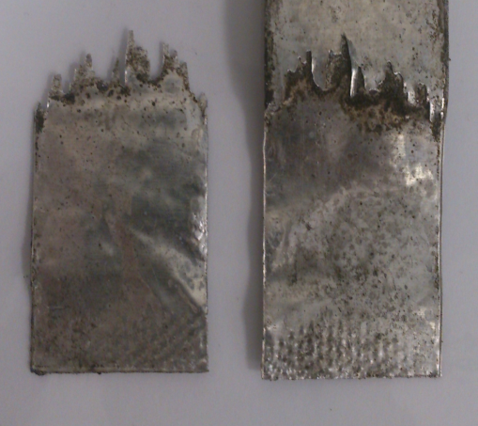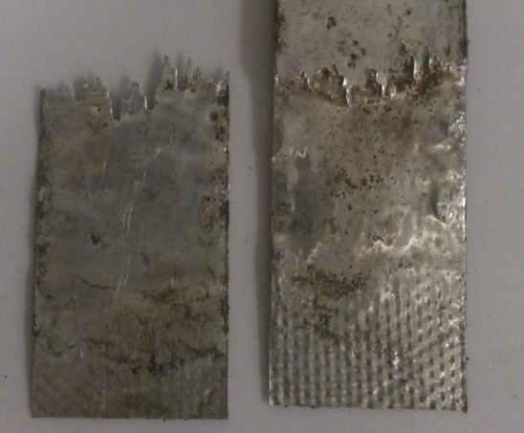
Figure 6: Fracture Modes of Aluminium Peel Test
The two failure modes:
1. When there was a clear break at the beginning of a soldered region (when a load was applied) indicating an effective bond giving a high load ranging from 61.5-56N.
2. When a sample did not break at the beginning of soldered region but failed as the breaking points grew under loading. Typically such failure resulted in soldered loads of around 45.5N.
The peel test used in the experiments did not behave in the same way as a peel test applied to adhesive bonds which tend to fail uniformly across the bond interface. When applied to peel specimens the method of failure was different and tended to propagate from a series of ‘contact points’. A contact point is defined as a small region within the brazed zone that was fully bonded. Under peeling action a contact point remains bonded with un-bonded material around it tearing during failure to give the effect of ‘teeth’. The more contact points present in a sample the higher the resistance to peeling with shorter ‘teeth’ being observed. The peel test results were essentially a qualitative measure of failure of the many contact points within a brazed interface (with contact points failing at differing loads). However, the test proved useful as an indication of overall metal joining effectiveness and did produce a proportional load response. In all the specimens, the failure was recorded according to BS EN ISO 10365:1995 [30]. The failure pattern was always cohesive substrate failure (CSF) meaning that one of the substrates failed.

Crosshead speed of 10mm/min
The results of the peel test at a peel rate of 10mm/min yielded a maximum peeling force of 55.5N and a minimum peeling force of 45.5N as shown in Fig. 7.

Figure 7: Peel test at 10mm/min
Table 1 calculates the average force (from the graph) and peel strength which is obtained by dividing the maximum force with the cross-sectional area (0.1 mm x 25 mm = 2.5 mm²) of each specimen.

Specimens | Maximum Peeling  Force (N) | Average Peeling  Force (N) | Peel Strength (N/mm²) | Type of Failure
S1 | 51 | 23.80 | 20.4 | Cohesive Substrate Failure
S2 | 50.5 | 16.85 | 20.2
S3 | 49 | 13.04 | 19.6
S4 | 45.5 | 13.56 | 18.2
S5 | 55.5 | 23.86 | 22.2
Average Peel Strength = 20.12 N/mm²
Table 1: Peel test calculations at 10mm/min

Crosshead speed of 50mm/min
The results of the peel test at a peel rate of 50mm/min yielded a maximum peeling force of 61.5N and a minimum peeling force of 45.5N as shown in Fig. 8.

Figure 8: Peel test at 50mm/min
Table 2 calculates the average force and peel strength of each specimen.
Specimens | Maximum Peeling  Force (N) | Average Peeling  Force (N) | Peel Strength (N/mm²) | Type of Failure
S1 | 61.5 | 30.33 | 24.6 | Cohesive Substrate Failure
S2 | 53.5 | 27.70 | 21.4
S3 | 49 | 18.97 | 19.6
S4 | 47 | 26.99 | 18.8
S5 | 45.5 | 12.74 | 18.2
Average Peel Strength = 20.52 N/mm²
Table 2: Peel test calculations at 50mm/min

Crosshead speed of 100mm/min
The results of the peel test at a peel rate of 100mm/min yielded a maximum peeling force of 56N and a minimum peeling force of 46N as shown in Fig. 9.

Figure 9: Peel test at 100mm/min
Table 3 calculates the average force and peel strength of each specimen.
Specimens | Maximum Peeling  Force (N) | Average Peeling  Force (N) | Peel Strength (N/mm²) | Type of Failure
S1 | 48.5 | 19.14 | 19.4 | Cohesive Substrate Failure
S2 | 52 | 21.41 | 20.8
S3 | 46 | 24.62 | 18.4
S4 | 56 | 20.78 | 22.4
S5 | 50 | 27.56 | 20
Average Peel Strength = 20.2 N/mm²
Table 3: Peel test calculations at 100mm/min
The test results show similar pattern as compared to the work done by Kong, Soar and Dickens [26] using UC to produce aluminium specimens for peel testing. They used aluminium 6061 foils (tensile strength=310MPa) that were 100 micron thick and this research was done using Al 99.5 grade 1050 H14 ½ hard temper foils (tensile strength=100MPa) of the same thickness. In case of UC, at high contact pressures (241kPa) and slow weld speeds (34.5 mm/s), the specimens failed through a crack-like geometry at the beginning of the weld region, at around 71.7 N, and represented failure in the single foil and not the welded region. This value was termed by the researchers as ‘critical peeling load’. Some specimens, however, tear within the weld region, propagating from the various contact points. The specimens were produced at different amplitudes corresponding to the minimum, medium and maximum amplitude of the UC equipment. All the specimens were tested at a cross-head speed of 50mm/min. Since the peel test was unable to indicate the weld strength of the specimens beyond the critical peeling load, peel strength was calculated at this point and it comes out to be 28.68N/mm² or 28.68MPa (71.7N/2.5mm²=28.68 N/mm²). However, in comparison, the peel strength is roughly 0.0925 times the tensile strength of aluminium 6061. The specimens produced by CMFM were tested at three different cross-head speeds and one of those speeds was 50mm/min. All the results yielded failure modes similar to each other and to the tests performed by Kong, Soar and Dickens. The speed had no effect on the peeling loads and the peeling strength was a constant 20N/mm² for all the three sets of tests. This value of peel strength, in comparison comes out to be 0.2 times the tensile strength of Al 99.5. This goes to show that the specimens produced by CMFM have relatively higher peel strength as compared to the specimens produced by UC (Fig. 10).
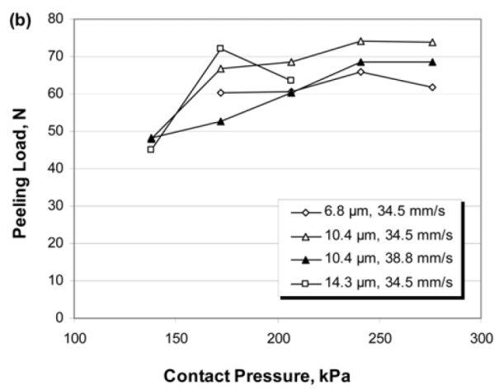
Figure 10: Comparison of peel tests, (a) CMFM test results (b) UC test results

Results from Corrosion Test of Aluminium Specimens
As mentioned before, galvanic corrosion is a major concern and any corrosion in the bond/foil interface would seriously undermine the strength of the specimen. This test was performed to assess the peel strength of the specimens and whether or not it is affected by corrosion. The aluminium peel specimens were put in a cylindrical container for 24 hours.
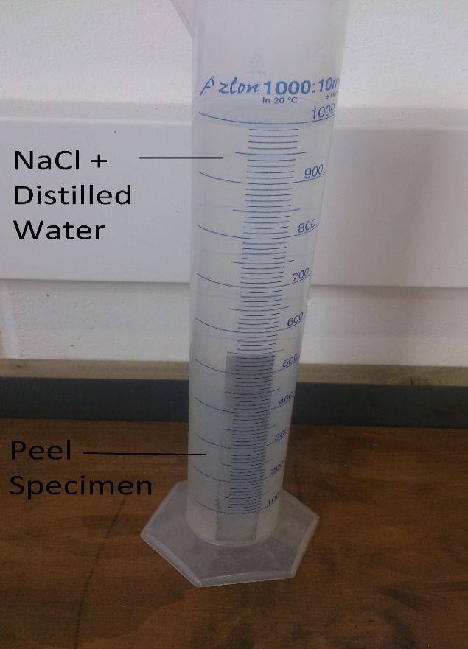
Figure 11: Corrosion Testing
The pH of the solution was checked, by the use of pH strips, when the specimen was put in the container and when it was taken out. The value was 7.0 in both cases and is in the acceptable range. Afterwards, the specimens were tested on the tensile testing machine at a peel rate of 10mm/min and yielded similar fracture modes (Fig. 12) as previous peel test specimens. The resulting maximum peeling force for the tests was 55N and a minimum peeling force of 45.5N (Fig. 13). The peel strength calculation is shown in Table 4.
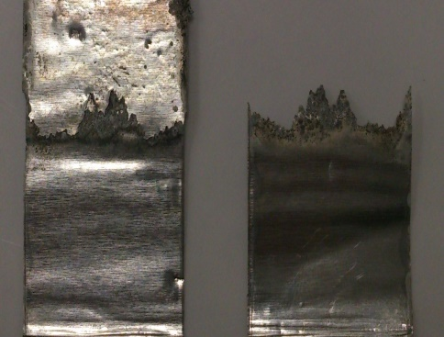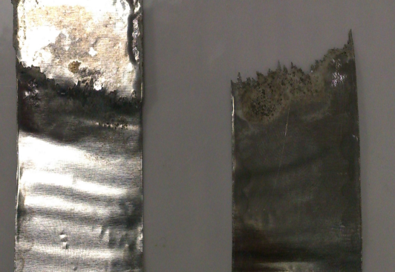
Figure 12: Fracture modes of aluminium peel test after corrosion testing

Figure 13: Peel test at 10mm/min after corrosion testing
Specimens | Maximum Peeling  Force (N) | Average Peeling  Force (N) | Peel Strength (N/mm²) | Type of Failure
S1 | 45.5 | 16 | 18.2 | Cohesive Substrate Failure
S2 | 50.5 | 26.35 | 20.2
S3 | 52 | 20.15 | 20.8
S4 | 55 | 25.67 | 22
S5 | 47.5 | 18.69 | 19
Average Peel Strength = 20.04 N/mm²
Table 4: Peel test calculations at 10mm/min after corrosion testing
An average peel strength of 20.04 N/mm² shows that the mechanical properties of the specimens were not affected by corrosion.

Results from T-peel Test of Aluminium/Copper Specimens
In a peel test, when the two ends of the specimen are pulled apart, all stress is concentrated in a single line at the end where the bond is being destroyed. Stiffness of the substrates has significant effects on the results: the stiffer the substrate, the more the load tends to be distributed away from the centre line at the leading edge of the bond, causing the apparatus to measure cleavage rather than peel. Since copper is more stiff than aluminium, it was held in the movable gripper as recommended by BS EN ISO 11339:2010. The test was carried out at a peel rate of 10mm/min and similar fracture modes were observed as with aluminium peel test specimens (Fig. 14). It is evident that aluminium caused the fracture of the specimen and not copper because copper is stronger than aluminium having a greater modulus of elasticity.
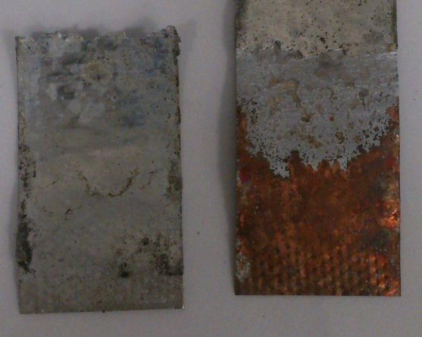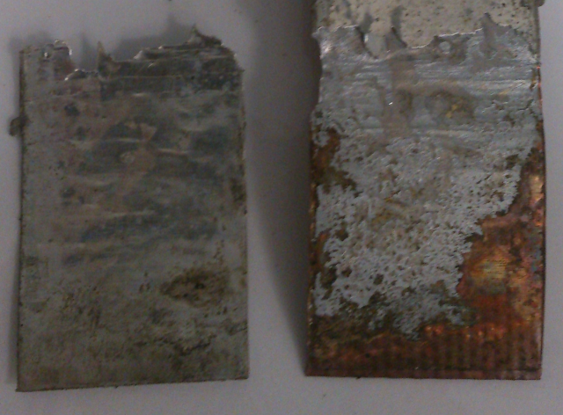
Figure 14: Fracture modes of aluminium/copper peel test

The test for aluminium/copper peel specimens yielded a maximum peeling force of 54N and a minimum peeling force of 47.5N as shown in Fig. 15.

Figure 15: Peel test of aluminium/copper specimens
Table 5 shows the calculated average peeling force and peel strength.
Specimens | Maximum Peeling  Force (N) | Average Peeling  Force (N) | Peel Strength (N/mm²) | Type of Failure
S1 | 54 | 27.9 | 21.6 | Cohesive Substrate Failure
S2 | 49.5 | 16.9 | 19.8
S3 | 51 | 17.18 | 20.4
S4 | 47.5 | 11 | 19
S5 | 48 | 17.1 | 19.2
Average Peel Strength = 20 N/mm²
Table 5: Peel test calculations of aluminium/copper specimens

Results from Dog-bone Tensile Test
This test was done to assess the effect of brazing on a multi-layer structure. In a multi-layer structure, braze is on both sides of the foil and it will truly test the integrity of the bond among the layers when subjected to tensile loading. The test showed that the maximum force value for the solid aluminium 1050 specimen is 4.484 kN and its curve has well defined elastic and plastic regions as is expected from an aluminium alloy. Considerable necking is also observed at the point of failure. On the other hand, the composite aluminium (produced by the proposed process) showed maximum force value of 4.853 kN making it 8% stronger in comparison. This test clearly demonstrates that the bond produced by the proposed process is much stronger than the product manufactured from traditional methods. Fig. 16 shows the fracture modes and Fig. 17 shows the comparison between the two specimens.
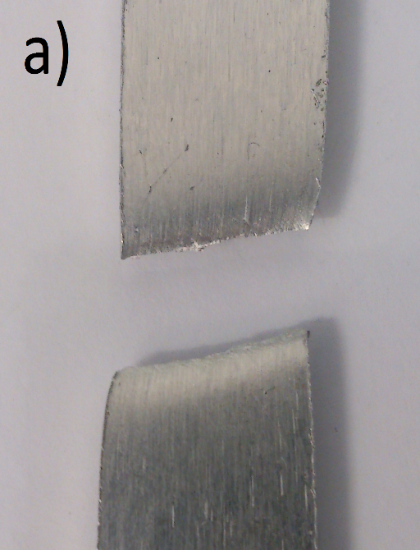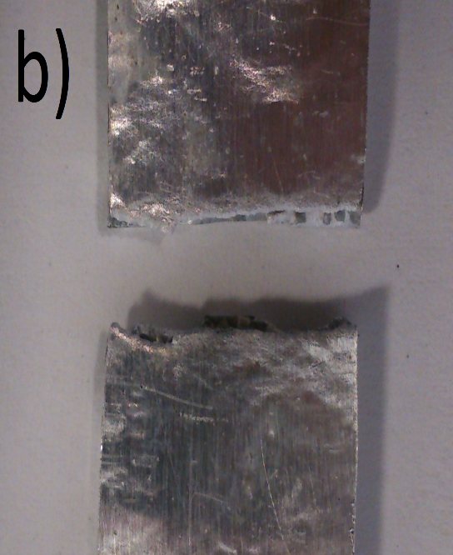
Figure 16: Fracture modes of the test specimens

Figure 17: Comparative Tensile Test
The reason for the high strength of the specimens is very basic. The yield strength of aluminium is 75 MPa whereas the yield strength of the paste used is 40 MPa and because the paste is forming an intermetallic bond with the metal, these strengths tend to add up theoretically [31]. In theory, the strength keep on increasing with the increase in the number of layers. Practical testing does not show the same increase in strength as in theory but there is some addition in strength nonetheless which is evident from the Fig. 17. Furthermore, the layer of pate stops the metal atoms from slipping when stress is applied and thus prohibiting any dislocations. Both the specimens follow the same elastic region and show almost identical behaviour. Aluminium being a ductile metal has a large plastic deformation range before fracturing whereas the composite specimen does not behave in the same manner. Due to the presence of intermetallic bonds among the layers, it shows high strength but a smaller plastic deformation range before fracturing. The bonds prevent the aluminium layers from following their ductile nature resulting in a rather smaller plastic deformation range. The presence of bonds is also responsible for a much less percentage elongation of the specimen (2.8%) as compared to the parent aluminium (20.5%).

Conclusions
The peel tests were performed to assess the integrity of the proposed process and whether or not it has the capability to challenge the existing metal prototyping technologies. Peel specimens of 100 micron thick Al 99.5 foils were produced and tested first at different peel rates and then tested for galvanic corrosion. Peel test was also performed on 100 micron thick Al 99.5 and 99.99% pure copper foils. The tensile test showed that the process has the capability to produce stronger parts compares to traditional methods. The experimental results are consistent and show that the proposed process has the potential to be a strong candidate in the field of metal prototyping. The research work presented in this paper led to the following conclusions:
- Peel specimens produced by CMFM are not affected by the peel rate and exhibit similar failure modes. They all break at the beginning of the bonded region and do not propagate throughout the length of the specimen. This shows that the interface between the foils and the bond is strong enough to allow them to work together as a single layer rather than two layers joined together.
- The peel strength at 10mm/min, 50mm/min and 100 mm/min is fairly consistent at 20.12 N/mm², 20.52 N/mm² and 20.2 N/mm² respectively.
- The relative peel strength of specimens produced by CMFM is twice the peel strength of specimens produced by UC.
- The specimens produced by CMFM do not face the problem of galvanic corrosion and when tested yielded a peel strength of 20.04 N/mm².
- From the peel tests of 100 micron thick aluminium specimens, it could be concluded that the peel strength is about 0.2 times the tensile strength of Al 99.5 (100 N/mm²).
- CMFM is fully capable of producing composites with the same effectiveness as single material specimens. The peel strength of aluminium/copper peel specimens comes out to be 20 N/mm².
- Tensile testing show that composite aluminium (part produced by CMFM) is 8% stronger than parent aluminium (part produced out of a solid aluminium 1050 block).

Funding Statement
This research received no specific grant from any funding agency in the public, commercial, or not-for-profit sectors.
Supplementary Materials
Graphs and any data related to the research can be made available on request.

References
[1] Gaard A, Krakhmalev P, Bergstrom J. Microstructural characterization and wear behaviour of (Fe, Ni) – TiC MMC prepared by DMLS. J. Alloys Compd. 2006; 421 (1–2): 166–71.
[2] Mazzoli A, Moriconi G, Pauri MG. Characterization of an aluminium-filled polyamide powder for applications in selective laser sintering. Mater. Des. 2007; 28 (3): 993–1000.
[3] Cormier D, Harrysson O, West, H. Characterization of H13 steel produced via electron beam melting. Rapid Prototyping Journal 2002, 10 (1): 35-41.
[4] Cansizoglu O, Harrysson O, Cormier D, West H, Mahale T. Properties of Ti-6Al-4V non-stochastic lattice structures fabricated via electron beam melting. Material Science and Engineering A 2008; 492: 468-74.
[5] Facchini L, Magalini E, Robotti P, Molinari A, Hoges S, Wissenbach K. Ductility of a Ti-6Al-4V alloy produced by selective laser melting of pre-alloyed powders. Rapid Prototyping Journal 2010; 16 (6): 450-9.
[6] Pham DT, Gault RS. A comparison of rapid prototyping technologies. Int. J. Mach. Tools Manuf 1998; 38: 1257-87.
[7] Vandenbroucke B, Kruth JP. Selective laser melting of biocompatible metals for rapid manufacturing of medical parts. Rapid Prototyping Journal 2007; 13 (4): 196-203.
[8] Zaeh MF, Branner G. Investigations on residual stresses and deformations in selective laser melting. Prod. Eng. 2010; 4: 35-45.
[9] Hanninen J. Direct metal laser sintering. Adv. Mater. Processes 2002; 160: 33–36.
[10] Simchi A, Pohl H. Direct laser sintering of iron–graphite powder mixture. Material Science Engineering A 2004; 383 (2): 191–200.
[11] Prechtl M, Pursche L, Otto A. System Technology and data Preparation for Automated Laser Assisted Stacking of Metal Foil. In: Proc. of the 4th International Conference on Laser Assisted Net Shape Engineering – LANE, Germany; 2004. p. 601-610.
[12] Prechtl M, Otto A, Geiger M. Rapid Tooling by Laminated Object Manufacturing of Metal Foil. Trans Tech. 2005, 6-8: 303-312.
[13] Kong CY, Soar RC, Dickens PM. Characterization of aluminium alloys 6061 for the ultrasonic consolidation process. Materials Science Engineering A 2003; 363 (1–2): 99–106.
[14] Kong CY, Soar RC, Dickens PM. Optimal process parameters for ultrasonic consolidation of 3003 aluminium. J. Mater. Process. Technol. 2004; 146(2): 181–7.
[15] Kong CY, Soar RC. Fabrication of metal–matrix composites and adaptive composites using ultrasonic consolidation process. Materials Science Engineering A 2005; 412(1–2): 12–8.
[16] Janaki Ram GD, Yang Y, Stucker BE. Effect of process parameters on bond formation during ultrasonic consolidation of aluminium alloy 3003. J. Manuf. Syst. 2006; 25(3): 221–38.
[17] Kong CY, Soar RC, Dickens PM. Ultrasonic consolidation for embedding SMA fibres within aluminium matrices. Compos. Struct. 2004; 66 (1–4): 421–7.
[18] Yang Y, Janaki Ram GD, Stucker BE. Bond formation and fibre embedment during ultrasonic consolidation. J. Mater. Process. Technol. 2009; 209 (10): 4915–24.
[19] Janaki Ram GD, Robinson C, Yang Y, Stucker BE. Use of ultrasonic consolidation for formation of multi-material structures. Rapid Prototyping Journal 2007; 13 (4): 226–35.
[20] Butt J, Mebrahtu H, Shirvani H (2015) A novel rapid prototyping process for the production of metal parts. International Journal of Advancements in Mechanical & Aeronautical Engineering, Vol. 2, pp. 15-18.
[21] Fenton E A. Brazing Manual. New York, N.Y.: American Welding Society; 1963.
[22] Byrnes Jr ER. Vacuum flux less brazing of aluminium. Welding Journal 1971; 50 (10): 712-716.
[23] Rivard John D, Sabau Adrian S, Schwartz, M M. Brazing. Metals Park, Ohio: ASM International; 1987.
[24] Choi JW, Oh TS. Peel strength and peel angle measured by the T-peel test on Cr/BPDA-PDA interface. J. Adhes. Sci. Technol. 2001; 15: 139–152.
[25] Kim J, Kim KS, Kim YH. Mechanical effects of peel adhesion test. J. Adhes. Sci. Technol. 1989; 3: 175–187.
[26] Kong C, Soar RC, Dickens PM. A model for weld strength in ultrasonically consolidated components. Proceedings of the Institution of Mechanical Engineers, Part C: Journal of Mechanical Engineering Science 2005; 219 (1): 83-91
[27] BS EN ISO 11339:2010. Adhesives—T-peel test for flexible-to-flexible bonded assemblies.
[28] BS EN ISO 11130:2010. Corrosion of metals and alloys—Alternate immersion test in salt solution.
[29] BS EN ISO 6892-1:2009, Metallic materials — Tensile testing, Part 1: Method of test at ambient temperature.
[30] BS EN ISO 10365:1995. Adhesives—Designation of main failure patterns.
[31] Anglia Polytechnic University, Hassan Shirvani (2000) Honeycomb structure, method of forming a honeycomb structure and method of joining aluminium or aluminium alloy bodies. GB Patent: WO0033997 (A1).

