Norfolk *et al.* Butterfly diversity along an agricultural gradient

**Diversity and composition of tropical butterflies along an Afromontane agricultural gradient in the Jimma Highlands, Ethiopia**

Olivia Norfolk1,2, Abebe Asale3, Tsegab Temesgen3, Dereje Denu3, Philip J. Platts4, Rob Marchant1 and Delenasaw Yewhalaw5,6

1 York Institute for Tropical Ecosystems, Environment Department, University of York, Heslington, York, UK, YO10 5NG

2 Department of Life Sciences, Anglia Ruskin University, Cambridge, UK, CB1 1PT

3 Department of Biology, College of Natural Sciences, Jimma University, Jimma, Ethiopia

4 Department of Biology, University of York, Heslington, York, UK, YO10 5DD

5Department of Medical Laboratory Sciences and Pathology, College of Health Sciences, Jimma University, Jimma, Ethiopia

6Tropical and Infectious Diseases Research Center, Jimma University, Jimma, Ethiopia

Received _____: revision accepted____

ABSTRACT

Afromontane landscapes are typically characterised by a mosaic of smallholder farms and the biodiversity impacts of these practices will vary in accordance to local management and landscape context. Here we assess how tropical butterfly diversity is maintained across an agricultural landscape in the Jimma Highlands of Ethiopia. We used transect surveys to sample understory butterfly communities within degraded natural forest, semi-managed coffee forest (SMCF), exotic timber plantations, open woodland, croplands and pasture. Surveys were conducted in 29 one-hectare plots and repeated five times between January and June 2013. We found that natural forest supports higher butterfly diversity than all agricultural plots (measured with Hill’s numbers). SMCF and timber plantations retain relatively high abundance and diversity, but these metrics drop off sharply in open woodland, cropland and pasture. SMCF and timber plantations share the majority of their species with natural forest and support an equivalent abundance of forest-dependent species, with no increase in widespread species. There was some incongruence in the responses of families and sub-families, notably that Lycaenidae are strongly associated with open woodland and pasture. Adult butterflies clearly utilise forested agricultural practices such as SMCF and timber plantations, but species diversity declines steeply with distance from natural forest suggesting that earlier life-stages may depend on host plants and/or microclimatic conditions that are lost under agricultural management. From a management perspective, the protection of natural forest remains a priority for tropical butterfly conservation, but understanding functioning of the wider landscape mosaic is important as SMCF and timber plantations may act as habitat corridors that facilitate movement between forest fragments.

*Keywords:* Africa; agroforestry; cropland; coffee; Ethiopia; farming; land-use change; tropical forest

Tropical deforestation is a major driver of biodiversity declines (Dirzo & Raven 2003, Gaston *et al.* 2003), one which continues at pace in response to anthropological pressures such as increasing food and timber demands (Geist & Lambin 2002, Lawrence & Vandecar 2015, Lewis *et al.* 2015). Expanding production landscapes are unlikely to match the conservation value of natural forests, but many traditional agricultural systems can provide an important refuge for biodiversity (Torquebiau 1992, Bhagwat *et al.* 2008, Jose 2009). Afromontane landscapes tend to incorporate a broad range of agricultural systems, ranging from traditional agroforestry systems, mono-culture timber plantations, mixed croplands to pasture. Understanding the extent to which these different agricultural systems contribute towards the maintenance of tropical biodiversity will help inform future landscape management and may facilitate the development of nature-based strategies that enhance food production whilst maintaining biodiversity and ecosystem services (Fischer *et al.* 2014).

Tropical butterflies are a highly diverse group of organisms (Bonebrake *et al.* 2010) that due to short generation times and high mobility tend to exhibit high sensitivity to land-use change (Lawton *et al.* 1998, Thomas *et al.* 2001). In general, butterfly diversity tends to decrease when tropical forest is converted into agricultural land, but the magnitude of this effect can differ quite considerably between agricultural systems. Studies in Indonesia and South America have found that agricultural landscapes support reduced butterfly species richness when compared to tropical forest, but that agroforestry systems support higher numbers of species than annual cropland and pasture (Schulze *et al.* 2004, Barlow *et al.* 2007, Francesconi *et al.* 2013). In Western Africa, cashew forest plantations have been linked to a reduction in butterfly species richness (Vasconcelos *et al.* 2015) as have annual cultures, though Cameroonian agroforests can support species richness equal to natural forest (Bobo *et al.* 2006). The conservation value of agricultural systems can also vary in accordance with landscape context and tends to decrease with isolation from natural forest (Horner‐Devine *et al.* 2003, Schulze *et al.* 2004, Munyuli 2013). In Costa Rica, plots incorporating both agroforestry and natural forest supported higher species richness than forest plots alone (Horner‐Devine *et al.* 2003), further emphasising the importance of assessing agricultural impacts in the context of the wider landscape.

In Ethiopia, forest cover has declined from 40% to 2.7% since the beginning of the 20th century, primarily as a result of expanding agricultural pressures (Pohjonen & Pukkala 1990). The Ethiopian Highlands are a major component of the Eastern Afromontane Biodiversity Hotspot (Mittermeier *et al*. 2004), covering half of its area, yet the impacts of agricultural expansion on biodiversity remain relatively understudied. Highland communities such as the Jimma Highlands (Fig S1) have a long history of coffee production, with wild coffee traditionally harvested from natural forests. To increase yields coffee growers modify natural forests by thinning trees and removing lianas and shrubs. These semi-managed coffee forests (SMCFs) form a characteristic feature of the Jimma Highlands and the retention of canopy trees means that they are likely to play a valuable role in the conservation of forest-dependent wildlife, especially when compared with more intensive forms of land use. Indeed Ethiopian shaded coffee has been shown to support high levels of bird diversity (Buechley *et al.* 2015) and may have similar benefits for tropical butterflies in the region.

The Jimma Highlands also support exotic timber plantations which have expanded five-fold in the past 20 years due to increasing demands for timber and firewood (Bekele 2011). These monoculture plantations do not retain native forest trees but do support some ground flora and understory species associated in un-cleared forest. At lower elevations agricultural practices become more intensive and are typified by croplands of annual cultivars and pasture. This study assesses the relative value of these agricultural systems in terms of tropical butterfly conservation, comparing butterfly abundance, diversity and composition along a land-use gradient ranging from natural forest to SMCF, timber plantation, open woodland, cropland and pasture. We consider how local land use, tree diversity and landscape factors influence butterfly communities, allowing us to assess the relative contribution that different agricultural practices make towards butterfly conservation in the region.

**METHODS**

Study site. - The study took place in the Jimma Highlands of south-western Ethiopia, along a 20 km transect running between the Gumay and Setema Districts. The study transect spanned an altitudinal gradient of 1500 m to 2226 m and incorporated a range of land-use types that are representative of the region, from the intensively managed pasture and cropland associated with the lowlands, up towards the lesser disturbed forest of the highlands (Fig S1). Land use was classified into six distinct categories: natural forest, semi-managed coffee forest (SMCF), timber plantation, open woodland, cropland and pasture. The characteristics of these land-use categories are defined in Table 1.

Butterfly surveys. -We conducted butterfly surveys in 29 × 1 ha plots (Fig. S1), encompassing natural forest (4 plots), SMCF (7), timber plantation (3), open woodland (4), cropland (6) and pasture (5). We selected plots through a stratified random sampling design, whereby we identified the main land-use types for the transect using 2008 SPOT5 satellite imagery (Hailu et al., 2014) and placed the 1 ha plots randomly in each land-use type. We surveyed each plot five times between January and June 2015, a period that encompassed the end of the dry season and the beginning of the rainy season (survey one, 31 December 2014 – 9 January 2015; survey two, 26 January – 5 February; survey 3, 28 March – 6 April; survey four, 2–11 May; survey five, 1-10 June).

Within each plot, we recorded butterflies along five 50 m line transects, spaced at 25 m intervals and traversed in alternate directions. We walked transects at a steady pace, recording all butterflies observed within 2.5 m either side of the transects and 5 m vertically. When possible we photographed butterflies during the transect counts to aid identification. The majority of individuals were identified to species level, but when species level identification was not possible, butterflies were classified into morpho-species. Surveys were all conducted between 0900 h and 1630 h on sunny, windless days. Data collected from the five transects were pooled per plot. Species were assigned to ecological habitat categories in accordance with Munyuli (2012) (nomenclature adapted from Larsen 1996): FDS, forest dependent species; FEW, forest edge and woodland species; MS, migratory species; OHPS, open habitat specialists; or WSS, widespread species.

Environmental variables.-We conducted tree surveys in all 29 plots in April 2014. We identified to species level all woody stems with a diameter at breast height (dbh) ≥ 10 cm. Using these data we calculated stem density and tree species richness per 1 ha plot. We also surveyed herbaceous plants and shrubs in five 1 m × 1 m quadrats that were randomly distributed within each plot, identifying all individuals to species level and then collated these data per plot.

In order to consider the effect of isolation from natural forest, we estimated linear distance from each sampling point to the nearest patch of natural forest using land cover data that was created using a supervised classification of SPOT satellite imagery for the year 2008 (Hailu et al., 2014). Plots were also categorised into five altitudinal bands for analyses: 1) 1500-1636 m; 2) 1637-1779 m; 3) 1780-1836 m; 4) 1837- 2089 m and 5) 2090- 2226 m.

Statistical analysis.- Statistical analyses were conducted in R version 3.2 (R Core Team, 2015) using the vegan package (Oksanen et al. 2012). Species accumulation curves were created for each land-use type. Alpha diversity was calculated for each point count using Hill’s numbers (Hill 1973). Hill's numbers are defined to the order of q (qD), whereby parameter q indicates the weight given towards rare or common species. 0D (species richness) is insensitive to relative frequencies, and is therefore weighted towards rare species, 1D (exponential of Shannon) is weighted towards common species, and 2D (inverse Simpson) is weighted towards abundant species. These diversity indices are particularly useful because they are scalable and can provide insight into the representation of rare, common and abundant species within different land-use types (Jost 2006, Tuomisto 2010, Chao et al. 2012).

Pair-wise species similarity was calculated between natural forest and the five other land-use types (Forest-Plantation, Forest-SMCF, Forest-Woodland, Forest-Cropland, Forest-Pasture). Species similarity was also weighted by the aforementioned q to provide insight into the relative abundance of those shared species; q=0 was calculated as the Sorenson similarity index (insensitive to species abundance), q=1 as the Horn index (weighted towards common species) and q=2 as the Morisita index (weighted towards abundant species) (Chao et al. 2012). This combination of metrics provides insight into not only the proportion of species shared, but the relative abundances of those shared species

Linear mixed-effect models were used to assess the impact of land use and environmental variables on butterfly abundance and all three measures of Hill’s diversity using the lme4 package (Bates 2005). Response variables were log-transformed to normalise the data. The fixed effects included in the full models were: 1) management type, 2) distance from nearest patch of natural forest (considered zero for plots within natural forest) and 3) vegetation (tree density, tree species richness, herb species richness, shrub species richness). Initial investigation suggested that there was considerable seasonal variation in abundance and species richness. To account for this temporal variation in the replicated plots, we included survey round as a random intercept. We also included altitudinal zone as a random intercept to account for spatial autocorrelation of plots along the altitudinal gradient. Best fitting models were selected using the dredge function in R, which returned models with the lowest AIC values (delta AIC < 4). The strength of the fixed effects retained in the best fitting models were assessed using marginal R2 values calculated using the MuMIn package (Barton 2014) and their significance was determined by comparing the fit of subsequent models using Chi-squared tests (Zuur et al. 2009). Equivalent models were also run for butterfly abundance within the five ecological habitat categories (FDS, FEW, MS, OHPS and WSS), and within the six most abundant sub-families (Coliadinae, Pierinae, Satyrinae, Heliconiinae, Lycaeninae and Papilioninae).

Non-metric multidimensional scaling (NDMS) was used to assess how community composition was affected by land use. This unconstrained ordination technique collapses the species data into two dimensions, allowing differences between land-use categories to be visualised. Because it relies upon rank-orders (rather than absolute abundance) it can accommodate non-linear species responses, allowing the detection of underlying responses to environmental change (Oksanen et al. 2012). The significance of land use was assessed using permutation tests (999 permutations) with the envfit function in R.

**RESULTS**

A total of 6616 butterflies were recorded, belonging to 64 species (and six morpho-species), the majority of which were fruit-feeding butterflies from the family Nymphalidae (44), followed by Pieridae (19), Papilionidae (5) and Lycaenidae (2) (Table S1 for full species list). Species accumulation curves had not reached their asymptotes, but there was clear separation between land-use types, with natural forest, timber plantation and SMCF exhibiting steeper rates of accumulation than open woodland, pasture and cropland (Fig. 1a). Estimated species richness was highest within timber plantations (Chao ± SE: 79 ± 17), followed by SMCF (72 ± 9) and forest (64 ± 3). Estimated species richness was similar in open woodland (48 ± 6), pasture (51 ± 12) and cropland (49 ± 11). Of the 70 recorded species, three nymphalid species were unique to natural forest (*Précis octavia, Charaxes karkloof* and *Acraea cerasa*), two to SMCF (*Acraea alciope* and *Junonia natalica*), one to woodland (*Pseudacraea eurytus*) and one to pasture (*Junonia hierta*). Timber plantation and cropland did not contain any unique species. The most numerous species overall was *Colias electo* (16% of all individuals), which was found to be most abundant in natural forest, SMCF and plantation.

Butterfly abundance per plot differed significantly between land-use types (Table 2) and was highest in SMCF (Individuals per ha ± SE: 41 ± 5), natural forest (37 ± 6) and plantations (35 ±5). Open woodland supported intermediate levels of abundance (23 ± 6), but numbers dropped sharply in pasture (10 ± 3) and cropland (6 ± 1). Hill’s diversity per plot also differed significantly with land use at all levels of q (Table 2). Natural forest supported the highest levels of butterfly diversity (Fig. 1b) followed by plantation and SMCF. Open woodland supported intermediate levels of diversity, but pasture and cropland supported less than a quarter of the diversity associated with natural forest, SMCF and plantation. These trends were true at all levels of q, indicating higher numbers of rare, common and abundant species in the forested habitats. Diversity decreased steeply to the order of q in forest, plantations and SMCF indicating that high numbers of species occurred at low abundances, with fewer species common or abundant. Within pasture and cropland, diversity showed little decline to the order of q, indicating similar numbers of rare, common and abundant species.

Butterfly communities associated with timber plantation and SMFC exhibited high levels of species similarity with natural forest communities (Fig. 2). Similarity to forest was high for all orders of q (>80% of species shared), suggesting that not only are timber plantations and SMCF supporting similar species to those in the forest, but that those species are occurring at similar relative abundance. Open woodland, cropland and pasture showed much lower levels of similarity to natural forest communities. These habitats all exhibited a sharp drop in similarity between q=0 and q=1 suggesting that although approximately 60% of forest species were present in open woodland, pasture and cropland, the identities of common and abundant species differed considerably from those associated with natural forest.

In addition to land use, the best-fitting models included distance from the nearest patch of natural forest, with butterfly abundance and diversity (at all orders of q) declining with distance (Table 2). At distances of 500 m diversity was approximately half of that associated with plots adjacent to natural forest, with diversity halving again by 1000 m (Fig. 3). Vegetative variables (tree density and tree, herb and liana species richness) explained little variation and were not retained in the final models.

Community composition. - Forty-two of the 70 recorded butterfly species were assigned to an ecological habitat category (Table S1), with the categorised species making up 78% of all observed individuals. The majority of butterflies were migratory species (57% of categorised observations), followed by open habitat specialists (20%) and widespread species (13%). Forest-dependent species and forest edge/woodland species made up just 7% and 1% of observations respectively. All ecological habitat categories exhibited a significant response to land use (Table S3), but the strength and direction of the trends differed between groups. Migratory and forest-dependent species showed the strongest responses to land use (Fig. 4a & c). Both groups occurred at similar abundance in natural forest, timber plantation and SMCF, with numbers dropping off sharply in the other land-use types. Forest edge/woodland species showed similar patterns, but trends were less pronounced (Fig. 4b). Open habitat specialists occurred in the lowest numbers within cropland and pasture and were most abundant within timber plantation (Fig. 4d). Widespread species showed a strong preference for open woodland (Fig. 4e).

All of the common families and sub-families were significantly affected by land use (Table S2), but again the strength and direction of the effect differed between groups (Fig. S2). Within the Pieridae, the abundance of Coliadinae was strongly influenced by land use, with butterflies occurring at high numbers within natural forest, timber plantation and SMCF, and declining sharply in open woodland, pasture and cropland (Fig. S2a). Pierinae showed a weaker response, but exhibited similar trends (Fig. S2b). The Nymphalidae also tended to occur at low abundance within open woodland, cropland and pasture, though trends differed between sub-families; butterflies from Satyrinae were most abundant within plantations (Fig. S2c-d), whereas those from Heliconiinae occurred at low numbers within plantations and were most abundant in natural forest. Papilonidae exhibited similar trends and were most abundant in forest, followed by plantations and SMCF (Fig. S2e). In contrast to the other sub-families, Lycaeninae occurred in low numbers in natural forest, timber plantation, SMCF and cropland, but were highly abundant in open woodland habitats, with intermediate numbers observed in pasture (Fig. S2f).

NDMS ordination showed that butterfly communities overlapped considerably between all land-use types, with no significant separation between the land-use categories (Fig. S3: R2=0.036, P=0.396). The ordination did reveal some differences in the composition of butterfly families, with species from Lycaenidae showing strong positive loadings with NDMS axis-1 in association with open woodland and pasture habitats.

**DISCUSSION**

Butterfly communities in the Jimma Highlands are strongly influenced by agricultural land use, with both abundance and species diversity decreasing sharply in non-wooded farmland such as cropland and pasture. Natural forest supports the highest level of butterfly diversity per plot, but estimates of species richness across all plots suggests that semi-managed coffee forests (SMCFs) and timber plantations support a similar number of species as natural forest, perhaps due to turnover of species between plots. Though SMCFs and plantations were utilised by adult forest butterflies, we found that both abundance and diversity declined with distance from natural forest. This suggests that the persistence of forest species may be contingent on larval host plants or microclimatic conditions present only in the natural forest.

Shaded coffee systems are frequently associated with positive biodiversity benefits, outperforming sun coffee farms in terms of butterfly species richness (Perfecto *et al.* 2003), bird abundance (Komar 2006) and subsequent avian ecosystem services such as pest control (Perfecto *et al.* 2004, Kellermann *et al.* 2008). Other studies have even found that coffee agroforest can support higher butterfly species richness than natural forest (Bobo *et al.* 2006). In the Jimma Highlands, we found that SMCF and timber plantations are utilised by equally diverse butterfly communities, despite the considerable reduction of tree species diversity within plantations. Exotic timber plantations tend to be considered in a less positive light from a conservation perspective, but studies in Brazil have found that although butterfly diversity decreases from natural forest into *Eucalyptus* plantations (Barlow *et al.* 2007), the plantations do support a relatively diverse community that benefit from the species-rich understory vegetation. Korean pine plantations have even been shown to maintain butterfly species richness at levels equivalent to natural forest (Lee *et al.* 2014). Our results confirm that timber plantations are utilised by adult forest butterflies, and at equivalent levels to more diverse agroforestry systems such as SMCF.

Species composition and ecological habitat categories. - Measures of species diversity can be misleading from a conservation perspective, as disturbed forest can often support elevated butterfly species richness as a consequence of increasing numbers of opportunistic and widespread species (Spitzer *et al.* 1993, Spitzer *et al.* 1997, Bobo *et al.* 2006). In our study, species similarity was extremely high between natural forest and SMCF and timber plantation (>80% species shared), suggesting that both of these agricultural habitats are being utilised by forest species and not just by opportunistic, widespread species. Consideration of ecological habitat categories confirmed that SMCF and timber plantation support similar numbers of forest-dependent species as natural forest, with no increase in the abundance of widespread species. However, timber plantations do appear to support elevated numbers of open habitat specialists from the sub-family Satyrinnae, a pattern also observed in Brazilian *Eucalyptus* plantations (Barlow *et al.* 2007). The Satyrianne exhibit diverse responses to forest disturbance, with some species preferring dense undergrowth (Brown & Freitas 2000, Ghazoul 2002) and others flourishing in the open habitats associated within forest disturbance (Daily & Ehrlich 1995, Shahabuddin & Terborgh 1999). Here the high numbers of open habitat specialists presumably reflects a lack of dense undergrowth within the plantations as compared to natural forest and SMCF.

Tropical butterflies can exhibit considerable vertical stratification from ground to canopy level (Molleman *et al.* 2006, Ribeiro *et al.* 2015), with canopy assemblages showing a higher susceptibility to decline in disturbed forest or logged forest than those found at ground level (Whitworth *et al.* 2016, Dumbrell & Hill 2005). Since we used transect surveys focussed on ground-level species, canopy species are likely to be under-represented in our results. Additional sampling of canopy assemblages could reveal a stronger decline from natural forest into SMCF and plantation forest, since the modified tree communities are likely to be associated with changes in canopy structure.

Proximity to natural forest. - We recorded a high diversity of adult butterflies in both SMCF and timber plantation, however habitat requirements for butterflies can vary through their life cycle. Larval stages often depend on a specific host plant and require distinct microclimatic conditions from their adult counterparts (Fartmann 2006), and though adult butterflies are frequently observed using forest gaps and edge habitats for basking and nectaring (Hill *et al*. 2001, Tropek & Konvicka 2010, Vlasanek *et al.* 2013), they typically depend on larval host plants in the understory. An intensive mark-release-recapture study in Papa New Guinea showed that many tropical butterflies can disperse up to 1 km from their larval host plant (Vlasanek *et al.* 2013), so the presence of adult butterflies within SMCF and timber plantation does not guarantee that these habitats in isolation could support the observed butterfly diversity.

This is consistent with our finding that butterfly abundance and diversity both decreased with distance from natural forest, with diversity declining by more than half over distances greater than 500 m. Other studies in tropical agricultural landscapes have found that agricultural land use has a stronger effect on butterfly diversity than proximity to forest (Perfecto *et al.* 2003, Francesconi *et al.* 2013), but on a wider scale, isolation from contiguous forest is negatively correlated with the species richness of fruit-feeding butterflies in Bornean forest fragments (Benedick *et al.* 2006). Landscape effects are known to impact butterfly meta-population dynamics in temperate systems (Hanski & Thomas 1994, Hill *et al.* 1996, Thomas *et al.* 2001), with occasional immigration from source populations rescuing isolated populations at marginal ‘sink’ sites from extinction (Hanski & Ovaskainen 2003). The meta-population dynamics of tropical systems are less well-established (Bonebrake *et al.* 2010), but large areas of forest are likely to act as source populations for more isolated forest fragments. Since SMCF and timber plantations are used by a wide diversity of adult butterflies they may be able to increase the permeability of the agricultural matrix by acting as habitat corridors that enable movement between remaining fragments of natural forest (Haddad & Tewksbury 2005).

Conclusions. - Tropical butterflies are adversely affected by agricultural conversion of natural forest in the Jimma Highlands, but the impact varies dramatically between agricultural practices. Butterfly abundance and diversity are particularly low in non-wooded habitats such as cropland and pasture, so the expansion of these agricultural practices would have strong negative implications for butterfly conservation in the region. Semi-managed coffee forests (SMCF) and timber plantations are utilised by a wide variety of forest butterflies, but diversity declines with increasing distance from natural forest suggesting that natural forest remains crucial to the butterfly life-cycle. From a management perspective, the maintenance of natural forest should be a priority for the conservation of forest butterflies, but SMCF and timber plantations may have the potential to act as habitat corridors that facilitate movement of adult butterflies between otherwise isolated forest fragments.

**ACKNOWLEDGEMENTS**

Funded by the Ministry for Foreign Affairs of Finland through the CHIESA project (<http://chiesa.icipe.org/>).

**Data Availability:** The data used in this study are archived at the Dryad Digital Repository (<http://dx.doi.org/10.5061/dryad.h6t7g>).

**LITERATURE CITED**

Barlow, J., I. S. Araujo, W. L. Overal, T. A. Gardner, F. Da Silva Mendes, I. R. Lake, and C. A. Peres. 2009. Diversity and composition of fruit-feeding butterflies in tropical Eucalyptus plantations. Plantation Forests and Biodiversity: Oxymoron or Opportunity?, pp. 165-180. Springer.

Barlow, J. O. S., W. L. Overal, I. S. Araujo, T. A. Gardner, and C. A. Peres. 2007. The value of primary, secondary and plantation forests for fruit-feeding butterflies in the Brazilian Amazon. J. Appl. Ecol. 44: 1001-1012.

Bekele, M. 2011. *Forest Plantations and Woodlots In Ethiopia: A Platform for Stakeholders in African Forestry*. African Forest Forum. Working Paper Series.

Benedick, S., J. K. Hill, N. Mustaffa, V. K. Chey, M. Maryati, J. B. Searle, M. Schilthuizen, and K. C. Hamer. 2006. Impacts of rain forest fragmentation on butterflies in northern Borneo: species richness, turnover and the value of small fragments. J. Appl. Ecol. 43: 967-977.

Bhagwat, S. A., K. J. Willis, H. J. B. Birks, and R. J. Whittaker. 2008. Agroforestry: a refuge for tropical biodiversity? Trends. Ecol. Evolut. 23: 261-267.

Bobo, K. S., M. Waltert, H. Fermon, J. Njokagbor, and M. Mühlenberg. 2006. From Forest to Farmland: Butterfly Diversity and Habitat Associations Along a Gradient of Forest Conversion in Southwestern Cameroon. J. Insect Conserv. 10: 29-42.

Bonebrake, T. C., L. C. Ponisio, C. L. Boggs, and P. R. Ehrlich. 2010. More than just indicators: A review of tropical butterfly ecology and conservation. Biol. Conserv. 143: 1831-1841.

Brooks, T. M., R. A. Mittermeier, C. G. Mittermeier, G. A. B. Da Fonseca, A. B. Rylands, W. R. Konstant, P. Flick, J. Pilgrim, S. Oldfield, G. Magin, and C. Hilton-Taylor. 2002. Habitat Loss and Extinction in the Hotspots of Biodiversity. Conserv. Biol. 16: 909-923.

Brown, K. S., and A. V. L. Freitas. 2000. Atlantic Forest Butterflies: Indicators for Landscape Conservation. Biotropica 32: 934-956.

Buechley, E. R., Ç. H. Şekercioğlu, A. Atickem, G. Gebremichael, J. K. Ndungu, B. A. Mahamued, T. Beyene, T. Mekonnen, and L. Lens. 2015. Importance of Ethiopian shade coffee farms for forest bird conservation. Biol. Conserv. 188: 50-60.

Daily, G.C. and P.R. Ehrlich. 1995. Preservation of biodiversity in small rain-forest patches – rapid evaluations using butterfly trapping. Biodiv. Conserv. 4: 35–55.

Dirzo, R., and P. H. Raven. 2003. Global state of biodiversity and loss. Ann. Rev. Environ. Res. 28: 137-167.

Dumbrell, A. J., and J. K. Hill. 2005. Impacts of selective logging on canopy and ground assemblages of tropical forest butterflies: Implications for sampling. Biol. Conserv. 125: 123-131.

Fartmann, T. 2006. Oviposition preferences, adjacency of old woodland and isolation explain the distribution of the Duke of Burgundy butterfly (*Hamearis lucina*) in calcareous grasslands in central Germany. Annales Zoologici Fennici. 43: 335-347.

Fischer, J., D. J. Abson, V. Butsic, M. J. Chappell, J. Ekroos, J. Hanspach, T. Kuemmerle, H. G. Smith, and H. Von Wehrden. 2014. Land Sparing Versus Land Sharing: Moving Forward. Conserv. Lett. 7: 149-157.

Francesconi, W., P. K. R. Nair, D. Levey, J. Daniels, and L. Cullen, Jr. 2013. Butterfly distribution in fragmented landscapes containing agroforestry practices in Southeastern Brazil. Agroforest. Syst. 87: 1321-1338.

Gaston, K. J., T. M. Blackburn, and K. K. Goldewijk. 2003. Habitat conversion and global avian biodiversity loss. Proc. Roy. Soc. London B: Biol. Sci. 270: 1293-1300.

Geist, H. J., and E. F. Lambin. 2002. Proximate Causes and Underlying Driving Forces of Tropical Deforestation Tropical forests are disappearing as the result of many pressures, both local and regional, acting in various combinations in different geographical locations. BioScience 52: 143-150.

Ghazoul, J. 2002. Impact of logging on the richness and diversity of forest butterflies in a tropical dry forest in Thailand. Biodiv. Conserv. 11: 521-541.

Haddad, N.M. and J.J. Tewksbury. 2005. Low‐quality habitat corridors as movement conduits for two butterfly species. Ecol. App. 15: 250-257.

Hailu, B.T., Maeda, E.E., Hurskainen, P. and Pellikka, P. K. E. 2014. Object-based image analysis for distinguishing indigenous and exotic forests in coffee production areas of Ethiopia. Appl. Geomatics 6: 207-214.

Hanski, I. 1999. *Metapopulation Ecology*. Oxford University Press, Oxford, UK.

Hanski, I., and O. Ovaskainen. 2003. Metapopulation theory for fragmented landscapes. Theor. Popul. Biol. 64: 119-127.

Hanski, I., and C. D. Thomas. 1994. Metapopulation dynamics and conservation: a spatially explicit model applied to butterflies. Biol. Conserv. 68: 167-180.

Hill, J. K., C. D. Thomas, and O. T. Lewis. 1996. Effects of Habitat Patch Size and Isolation on Dispersal by Hesperia comma Butterflies: Implications for Metapopulation Structure. J. Anim. Ecol. 65: 725-735.

Hill, J.K., Hamer, K.C., Tangah, J. and M. Dawood. 2001. Ecology of tropical butterflies in rainforest gaps. Oecologia. 128: 294–302.

Horner‐Devine, M. C., G. C. Daily, P. R. Ehrlich, and C. L. Boggs. 2003. Countryside biogeography of tropical butterflies. Conserv. Biol. 17: 168-177.

Jose, S. 2009. Agroforestry for ecosystem services and environmental benefits: an overview. Agroforest. Syst. 76: 1-10.

Kellermann, J. L., M. D. Johnson, A. M. Stercho, and S. C. Hackett. 2008. Ecological and economic services provided by birds on Jamaican Blue Mountain coffee farms. Conserv. Biol. 22: 1177-1185.

Komar, O. 2006. Ecology and conservation of birds in coffee plantations of El Salvador, Central America. PhD dissertation. University of Kansas, USA.

Larsen, T.B. 1996. *The Butterflies of Kenya and Their Natural History*, Oxford University Press, Oxford, UK.

Lawrence, D., and K. Vandecar. 2015. Effects of tropical deforestation on climate and agriculture. Nat. Climate Change 5: 27-36.

Lawton, J. H., D. E. Bignell, B. Bolton, G. F. Bloemers, P. Eggleton, P. M. Hammond, M. Hodda, R. D. Holt, T. B. Larsen, N. A. Mawdsley, N. E. Stork, D. S. Srivastava, and A. D. Watt. 1998. Biodiversity inventories, indicator taxa and effects of habitat modification in tropical forest. Nature 391: 72-76.

Lee, C. M., T.-S. Kwon, S.-S. Kim, J.-D. Sohn, and B.-W. Lee. 2014. Effects of forest degradation on butterfly communities in the Gwangneung Forest. Entomological Science 17: 293-301.

Lewis, S. L., D. P. Edwards, and D. Galbraith. 2015. Increasing human dominance of tropical forests. Science 349: 827-832.

Molleman, F., A. Kop, P. Brakefield, P. De Vries, And B. Zwaan. 2006. Vertical and Temporal Patterns of Biodiversity of Fruit-Feeding Butterflies in a Tropical Forest in Uganda. Biodiv. Conserv. 15: 107-121.

Munyuli, M.B., 2012. Butterfly diversity from farmlands of central Uganda. Psyche. Article ID: 481509: 1-23.

Munyuli, M. B. T. 2013. Drivers of species richness and abundance of butterflies in coffee–banana agroforests in Uganda. Int. J. Biodivers. Sci. Ecosyst. Serv. Manage. 9: 298-310.

Myers, N., R. A. Mittermeier, C. G. Mittermeier, G. A. B. Da Fonseca, and J. Kent. 2000. Biodiversity hotspots for conservation priorities. Nature 403: 853-858.

Perfecto, I., A. Mas, T. Dietsch, and J. Vandermeer. 2003. Conservation of biodiversity in coffee agroecosystems: a tri-taxa comparison in southern Mexico. Biodiv. Conserv. 12: 1239-1252.

Perfecto, I., J. H. Vandermeer, G. L. Bautista, G. I. Nunez, R. Greenberg, P. Bichier, and S. Langridge. 2004. Greater predation in shaded coffee farms: the role of resident neotropical birds. Ecol. 85: 2677-2681.

Pohjonen, V., and T. Pukkala. 1990. *Eucalyptus* globulus in Ethiopian forestry. Forest Ecol. Management 36: 19-31.

Ribeiro, D. B., M. R. Williams, A. Specht, and A. V. L. Freitas. 2015. Vertical and temporal variability in the probability of detection of fruit-feeding butterflies and moths (Lepidoptera) in tropical forest. Austral Entomol. 55:112-120.

Schulze, C., I. Steffan-Dewenter, and T. Tscharntke. 2004. Effects of Land Use on Butterfly Communities at the Rain Forest Margin: A Case Study from Central Sulawesi. In G. Gerold, M. Fremerey and E. Guhardja (Eds.). Land Use, Nature Conservation and the Stability of Rainforest Margins in Southeast Asia, pp. 281-297. Springer Berlin Heidelberg.

Shahabuddin, G. and J. W. Terborgh. 1999. Frugivorous butterflies in Venezuelan forest fragments: abundance, diversity and the effects of isolation. J. Trop. Ecol. 15: 703–722.

Thomas, J. A., N. A. D. Bourn, R. T. Clarke, K. E. Stewart, D. J. Simcox, G. S. Pearman, R. Curtis, and B. Goodger. 2001. The quality and isolation of habitat patches both determine where butterflies persist in fragmented landscapes. Proc. Roy. Soc. London B: Biol. Sci. 268: 1791-1796.

Torquebiau, E. 1992. Are tropical agroforestry home gardens sustainable? Agr, Ecosyst. Environ. 41: 189-207.

Tropek, R. and M. Konvicka. 2010. Forest eternal? Endemic butterflies of the Bamenda highlands, Cameroon, avoid close‐canopy forest. Afr. J. Ecol. 48: 428-437.

Vasconcelos, S., P. Rodrigues, L. Palma, L. F. Mendes, A. Palminha, L. Catarino, and P. Beja. 2015. Through the eye of a butterfly: Assessing biodiversity impacts of cashew expansion in West Africa. Biol. Conserv. 191: 779-786.

Vlasanek, P., Sam, L. and V. Novotny. 2013. Dispersal of butterflies in a New Guinea rainforest: using mark–recapture methods in a large, homogeneous habitat. Ecol. Ent. 38: 560-569.

Whitworth, A., J. Villacampa, A. Brown, R.P. Huarcaya, R. Downie and R. MacLeod 2016. Past Human Disturbance Effects upon Biodiversity are Greatest in the Canopy; A Case Study on Rainforest Butterflies. PloS one, 11: 0150520.

TABLE 1. Characteristics of the six land-use categories, with mean tree density and species richness per 1 ha plot.

|  |  |  |  |  |  |
| --- | --- | --- | --- | --- | --- |
|  | Description | Dominant tree species | Mean tree density (± SEM) |  | Mean tree sp. richness (± SEM) |
| Natural forest | Uncultivated forest dominated by indigenous trees | *Apodytes dimidiate, Galiniera saxifrage, Syzygium guineense Millettia ferruginea* and  *Chionanthus mildbraedii* | 258 ± 50 |  | 15 ± 1 |
| Timber plantation | Monoculture timber plantations | *Pinus patula, Grevillea robusta* or *Eucalyptus camaldulensis* | 751 ± 254 |  | 1 ± 0 |
| SMCF | Semi-managed coffee forest: mixed indigenous shade trees managed to provide optimal conditions for cultivation of *Coffea arabica* | *Croton macrostachyus, Albizia gummifera, Ehreta cymosa* and *Cordia africana* | 136 ± 27 |  | 15 ± 1 |
| Open woodland | Patchy open woodland | *Maesa lanceolate* and *Acacia abyssinica* | 122 ± 47 |  | 11 ± 1 |
| Pasture | Areas grazed by livestock | *Acacia abyssinica* and *Ficus vasta* | 10 ± 3 |  | 4 ± 1 |
| Cropland | Cultivated for annual crops (maize, sorghum and teff) | *Cordia africana* and *Acacia abyssinica* | 7 ± 2 |  | 2 ± 0.5 |
|  |  |  |  |  |  |

TABLE 2. Results from best-fitting linear mixed-effect models explaining butterfly abundance and Hill’s diversity (0D, 1D, 2D). Models included survey round and altitudinal zone as random effects. Marginal R2 values represent the variation explained by the associated fixed effect, with the significance determined by comparing the fit of subsequent models using Chi-squared. Asterisks indicate significance level (*** P< 0.001; ** P< 0.01).

|  |  |  |  |  |  |
| --- | --- | --- | --- | --- | --- |
|  |  | **Marginal R2GLMM** | **AIC** | **Δ AIC** | **χ2** |
| **Abundance** | ~ land-use + distance from natural forest | 0.51 | 377 | 0 |  |
|  | ~ land-use only | 0.48 | 388 | 11 | 53.54 *** |
|  | ~ distance from natural forest only | 0.19 | 422 | 44 | 8.79 ** |
|  |  |  |  |  |  |
| **0D** | ~ land-use + distance from natural forest | 0.49 | 207 | 0 |  |
|  | ~ land-use only | 0.48 | 218 | 11 | 53.04 *** |
|  | ~ distance from natural forest only | 0.14 | 274 | 68 | 9.10** |
|  |  |  |  |  |  |
|  | ~ land-use + distance from natural forest | 0.46 | 174 | 0 |  |
| **1D** | ~ land-use only | 0.46 | 183 | 10 | 72.92 *** |
|  | ~ distance from natural forest only | 0.13 | 222 | 49 | 7.53 ** |
|  |  |  |  |  |  |
|  | ~ land-use + distance from natural forest | 0.38 | 190 | 0 |  |
| **2D** | ~ land-use only | 0.38 | 200 | 10 | 55.25 *** |
|  | ~ distance from natural forest only | 0.10 | 221 | 31 | 7.20 ** |
|  |  |  |  |  |  |

FIGURE 1. (a) Species accumulation curves and (b) Hill’s diversity associated with the six land-use categories. Hill’s diversity indices represent the mean diversity per plot (± SEM) and are weighted to the order of q, which reflects the sensitivity of the indices to the relative abundance of species: q=0 is sensitive to rare species, q=1 is sensitive to common species and q=2 is sensitive to highly abundant species.

FIGURE 2. Species similarity of butterfly communities in the agricultural land-use categories as compared to natural forest. Species similarity is calculated using three indices that are weighted to the order of q; q=0 represents similarity of rare species, q=1 of common species and q=2 of abundant species.

FIGURE 3. Effect of distance from natural forest on butterfly abundance (a) and Hill’s diversity (b)-(d).

FIGURE 4. Impact of land use on butterfly abundance across five ecological habitat categories. Bars represent mean abundance per plot and error bars represent SEM.

**FIG 1**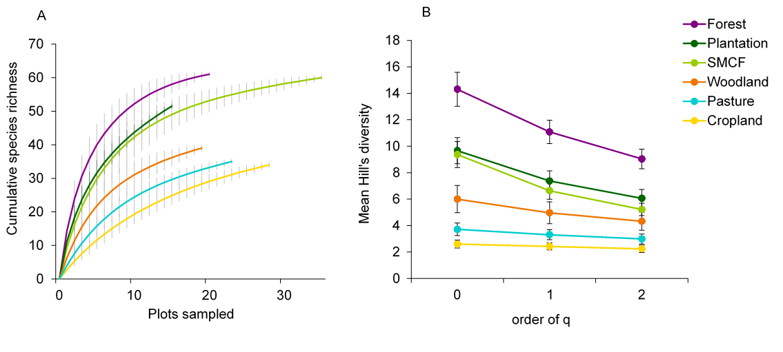

**FIG 2**

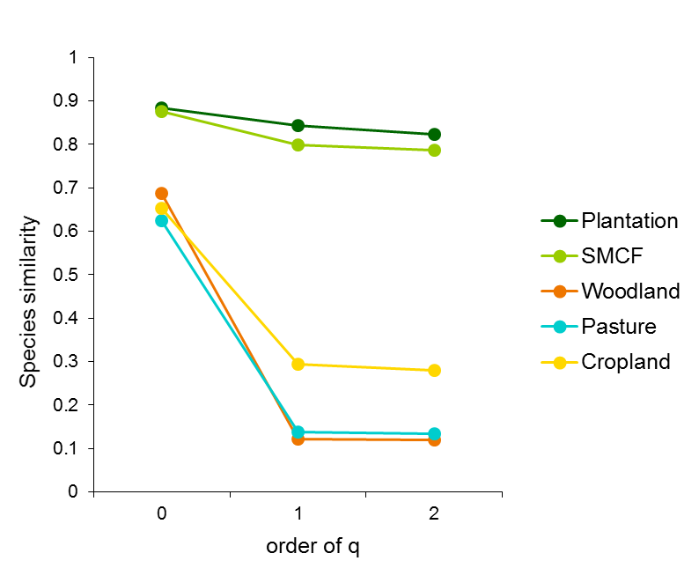

**FIG 3**

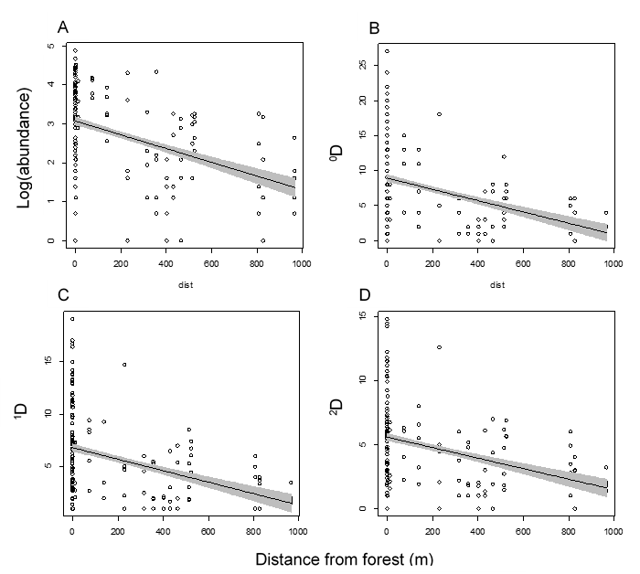

FIG 4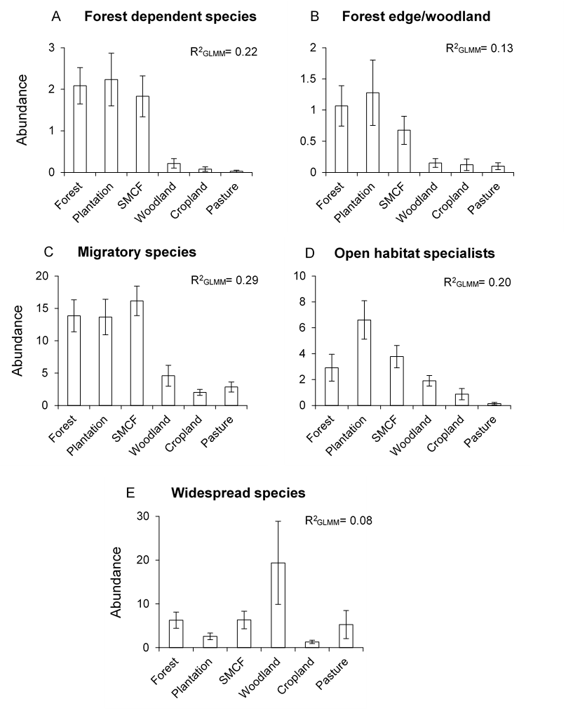

Table S1. List of butterfly species and their total abundance within each land-use category. Ecological habitat categories are defined according to Munyuli (2012): FDS= forest dependent species, FEW= forest edge and woodland species, MS= migratory species, OHPS= open habitat specialist, WSS= widespread species.

|  |  |  |  |  |  |  |  |  |
| --- | --- | --- | --- | --- | --- | --- | --- | --- |
|  | **Habitat cat.** |  | **NF** | **SMCF** | **PLNT** | **WD** | **CRP** | **PAST** |
| LYCAENIDAE |  |  |  |  |  |  |  |  |
| Polymmatinae |  |  |  |  |  |  |  |  |
| Polymmatinae sp1 |  |  |  | 31 |  | 156 |  | 64 |
| Polymmatinae sp2 |  |  |  | 41 |  | 195 |  | 58 |
| NYMPHALIDAE |  |  |  |  |  |  |  |  |
| Biblidinae |  |  |  |  |  |  |  |  |
| *Eurytela dryope* (Cramer, 1775) | WSS |  | 3 | 11 | 1 | 4 |  |  |
| *Sevenia boisduvali*  (Wallengren, 1857) | FDS |  | 1 | 22 | 3 |  |  |  |
| Charaxinae |  |  |  |  |  |  |  |  |
| *Charaxes brutus*(Cramer, 1779) | FEW |  | 1 | 5 | 5 |  | 3 | 1 |
| *Charaxes karkloof*van Someren & Jackson, 1957 |  |  | 1 |  |  |  |  |  |
| Danainae |  |  |  |  |  |  |  |  |
| *Amauris albimaculata*Butler, 1875 | FDS |  | 3 | 3 |  |  |  |  |
| *Amauris echeria*(Stoll, 1790) |  |  | 2 | 17 |  | 4 | 1 |  |
| *Amauris ochlea*(Boisduval, 1847) |  |  | 5 | 10 | 1 |  |  |  |
| *Danaus chrysippus*(Linnaeus, 1758) | MS |  | 6 | 7 | 4 | 1 | 1 | 3 |
| Danainane sp1 |  |  | 5 | 6 |  |  |  |  |
| Heliconiinae |  |  |  |  |  |  |  |  |
| *Acraea acara*Hewitson, 1865 |  |  | 16 | 4 | 6 | 1 | 1 | 1 |
| *Acraea aganice*Hewitson, 1852 |  |  | 9 |  | 3 |  |  |  |
| *Acraea alciope*Hewitson, 1852 | FDS |  |  | 5 |  |  |  |  |
| *Acraea anacreon* Trimen, 1868 |  |  | 5 |  | 2 |  |  |  |
| *Acraea cabira*Hopffer, 1855 | FEW |  | 7 |  | 2 |  |  |  |
| *Acraea cerasa* Hewitson, 1861 |  |  | 1 |  |  |  |  |  |
| *Acraea encedon* (L.) | WSS |  | 5 | 5 |  |  |  |  |
| *Acraea esebria* Hewitson, *1861* |  |  | 26 | 13 |  |  |  |  |
| *Acraea horta*(L.) |  |  | 8 | 1 | 2 | 1 | 1 |  |
| *Acraea lycoa*Godart, 1819 | FDS |  | 8 | 6 | 1 |  | 1 | 1 |
| *Acraea rahira* Boisduval, 1833 |  |  |  | 10 |  |  | 7 |  |
| *Acraea serena* (Fabricius, 1775) | WSS |  | 20 | 5 |  |  | 3 |  |
| *Phalanta phalantha* (Drury, [1773]) | MS |  | 3 | 22 | 1 | 11 | 3 | 10 |
| Libytheinae |  |  |  |  |  |  |  |  |
| *Libythea labdaca*Westwood, 1851 | MS |  | 9 | 11 | 14 | 9 |  |  |
| Limenitidinae |  |  |  |  |  |  |  |  |
| *Neptis goochii*Trimen, 1879 |  |  | 18 | 30 | 1 | 2 |  | 5 |
| *Neptis laeta* Overlaet, 1955 | WSS |  | 33 | 67 | 12 | 10 |  | 4 |
| *Neptis saclava* Boisduval, 1833 | WSS |  | 9 | 13 | 1 | 1 |  | 2 |
| *Pseudacraea eurytus* (L.) | FDS |  |  |  |  | 2 |  |  |
| Nymphalinae |  |  |  |  |  |  |  |  |
| *Hypolimnas anthedon*(Doubleday, 1845) |  |  | 7 | 13 | 1 | 2 | 4 | 3 |
| *Hypolimnas misippus*(Linnaeus, 1764) | MS |  | 6 | 10 |  | 1 |  | 2 |
| *Junonia hierta*(Fabricius, 1798) | MS |  |  |  |  |  |  | 1 |
| *Junonia natalica*(Felder & Felder, 1860) |  |  |  | 2 |  |  |  |  |
| *Junonia oenone*(Linnaeus, 1758) | WSS |  |  | 3 |  | 8 | 25 | 1 |
| *Junonia terea*(Drury, 1773) | WSS |  | 13 | 1 | 11 | 9 |  | 4 |
| *Precis octavia* (Cramer, 1777) | WSS |  | 10 |  |  |  |  |  |
| *Protogoniomorpha anacardii* (L.) | FDS |  | 5 | 12 | 10 | 1 |  |  |
| *Protogoniomorpha parhassus* (Drury, 1782) | FDS |  | 3 | 9 | 13 |  |  |  |
| *Vanessa dimorphica* (Howarth, 1966) |  |  | 6 |  | 14 |  | 2 | 1 |
| Satyrinae |  |  |  |  |  |  |  |  |
| *Bicyclus anynana*(Butler, 1879) | OHPS |  | 35 | 54 | 66 | 18 |  | 1 |
| *Bicyclus safitza*(Westwood, 1850) |  |  | 51 | 145 | 60 | 12 | 6 |  |
| Satyrinae sp1 |  |  | 9 | 17 | 12 | 4 | 4 | 1 |
| *Melanitis leda*(Linnaeus, 1758) | WSS |  | 2 | 11 | 2 | 5 | 13 |  |
| *Ypthima asterope* (Klug, 1832) | OHPS |  | 9 | 39 | 21 | 9 | 11 |  |
| *Ypthima impure* Elwes & Edwards, 189 | OHPS |  | 15 | 40 | 12 | 11 | 16 | 3 |
| PAPILIONIDAE |  |  |  |  |  |  |  |  |
| Papilioninae |  |  |  |  |  |  |  |  |
| *Graphium Leonidas* (Fabricius, 1793) | MS |  | 2 | 2 |  | 3 | 1 |  |
| *Papilio dardanus* Brown, 1776 | WSS |  | 28 | 20 | 4 |  |  |  |
| *Papilio demodocus* Esper, 1798 | MS |  | 14 | 12 | 3 | 2 | 2 | 1 |
| *Papilio euphranor* Trimen, 1868 |  |  | 4 | 6 | 7 |  |  | 1 |
| *Papilio nireus (L.)* | FEW |  | 11 | 19 | 11 | 3 | 1 | 2 |
| PIERIDAE |  |  |  |  |  |  |  |  |
| Coliadinae |  |  |  |  |  |  |  |  |
| *Catopsilia florella*(Fabricius, 1775) | MS |  | 9 | 1 | 1 |  |  |  |
| *Catopsilia gorgophone* (Boisduval, 1836) |  |  | 3 |  | 5 |  | 5 |  |
| *Catopsilia sp1* |  |  | 7 | 10 | 1 | 3 | 2 | 5 |
| *Colias electo* (L.) | MS |  | 95 | 374 | 102 | 32 | 2 | 3 |
| Coliadinae sp1 |  |  |  | 6 |  |  | 16 | 2 |
| *Eurema brigitta*(Stoll, [1780]) | MS |  | 8 | 10 | 14 |  | 3 |  |
| *Eurema desjardinsii* (Boisduval, 1833) | MS |  | 17 | 13 | 7 |  |  |  |
| *Eurema hecabe* (L.) | MS |  | 54 | 43 | 31 | 6 | 2 | 6 |
| Coliadinae sp2 |  |  | 6 | 12 | 1 |  |  |  |
| Pierinae |  |  |  |  |  |  |  |  |
| *Belenois aurota*(Fabricius, 1793) | MS |  | 16 | 4 | 14 | 6 | 23 | 11 |
| *Belenois creona* (Cramer, 1776) | MS |  | 13 | 15 | 4 | 5 | 2 | 11 |
| *Belenois gidica* (Godart, [1819]) | MS |  | 14 | 6 | 2 | 13 | 19 | 12 |
| *Belenois raffrayi*(Oberthür, 1878) | FDS |  | 6 | 9 |  |  |  |  |
| *Belenois zochalia* (Boisduval, 1836) |  |  | 21 | 14 | 11 | 7 | 10 | 16 |
| *Leptosia alcesta* (Stoll, [1782]) | WSS |  | 3 | 13 | 8 | 1 |  |  |
| *Mylothris rueppellii*(Koch, 1865) |  |  | 9 | 59 | 8 | 7 | 8 | 9 |
| *Pieris brassicae* (L.) |  |  | 22 | 46 | 4 | 1 | 3 | 3 |
| *Pieris rapae* (L.) |  |  | 6 | 19 | 1 |  | 1 | 1 |

Table S2. The effect of land-use on butterfly abundance within common sub-families. Results from linear mixed-effect models including survey month and altitudinal zone as random effects. Marginal R2 values represent the variation explained by land-use, with the significance determined by comparing the fit of land-use model to a null model using Chi-squared. Asterisks indicate significance level (*** P< 0.001; ** P< 0.01).

|  |  |  |  |  |  |
| --- | --- | --- | --- | --- | --- |
|  |  | Marginal R2GLMM | AIC | Delta AIC | χ2 (df=5) |
| Pieridae |  |  |  |  |  |
| *Coliadinae* | ~ Land-use | 0.54 | 381 | 0 | 107.47*** |
|  | ~ Null model |  | 472 | 91 |  |
| *Pierinae* | ~ Land-use | 0.17 | 352 | 0 |  |
|  | ~ Null model |  | 366 | 14 | 31.21*** |
| Nymphalydiae |  |  |  |  |  |
| *Satyrinane* | ~ Land-use | 0.43 | 381 | 0 | 75.02*** |
|  | ~ Null model |  | 440 | 59 |  |
| *Heliconiinae* | ~ Land-use | 0.20 | 357 | 0 | 31.26*** |
|  | ~ Null model |  | 370 | 13 |  |
| Lycaenidae | ~ Land-use | 0.10 | 381 | 0 | 19.09** |
| *Lycaeninae* | ~ Null model |  | 383 | 2 |  |
| Papilionidae | ~ Land-use | 0.19 | 280 | 0 | 32.58*** |
| *Papilioninae* | ~ Null model |  | 292 | 12 |  |

Table S3. The effect of land use on butterfly abundance within ecological habitat categories. Results from linear mixed-effect models including survey month and altitudinal zone as random effects. Marginal R2 values represent the variation explained by land-use, with the significance determined by comparing the fit of land-use model to a null model using Chi-squared. Asterisks indicate significance level (*** P< 0.001; ** P< 0.01).

|  |  |  |  |  |  |
| --- | --- | --- | --- | --- | --- |
|  |  | Marginal R2GLMM | AIC | Delta AIC | χ2 (df=5) |
| **Ecological habitat category** | |  |  |  |  |
| Forest Dependent | ~ Land-use | 0.22 | 593 | 0 | 23.44*** |
| ~ Null model |  | 609 | 15 |  |
| Forest Edge/Woodland | ~ Land-use | 0.13 | 455 | 0 | 13.81* |
| ~ Null model |  | 456 | 1 |  |
| Migratory species | ~ Land-use | 0.29 | 1021 | 0 | 24.36** |
| ~ Null model |  | 1056 | 35 |  |
| Open habitat specialists | ~ Land-use | 0.20 | 794 | 0 | 18.28** |
| ~ Null model |  | 813 | 19 |  |
| Widespread | ~ Land-use | 0.08 | 1231 | 0 | 0.013* |
|  | ~ Null model |  | 1259 | 28 |  |

Figure S1. Map of the study site in the Jimma Highlands, southwestern Ethiopia depicting main land-use categories along the altitudinal transect. White circles indicate locations of sampled plots.

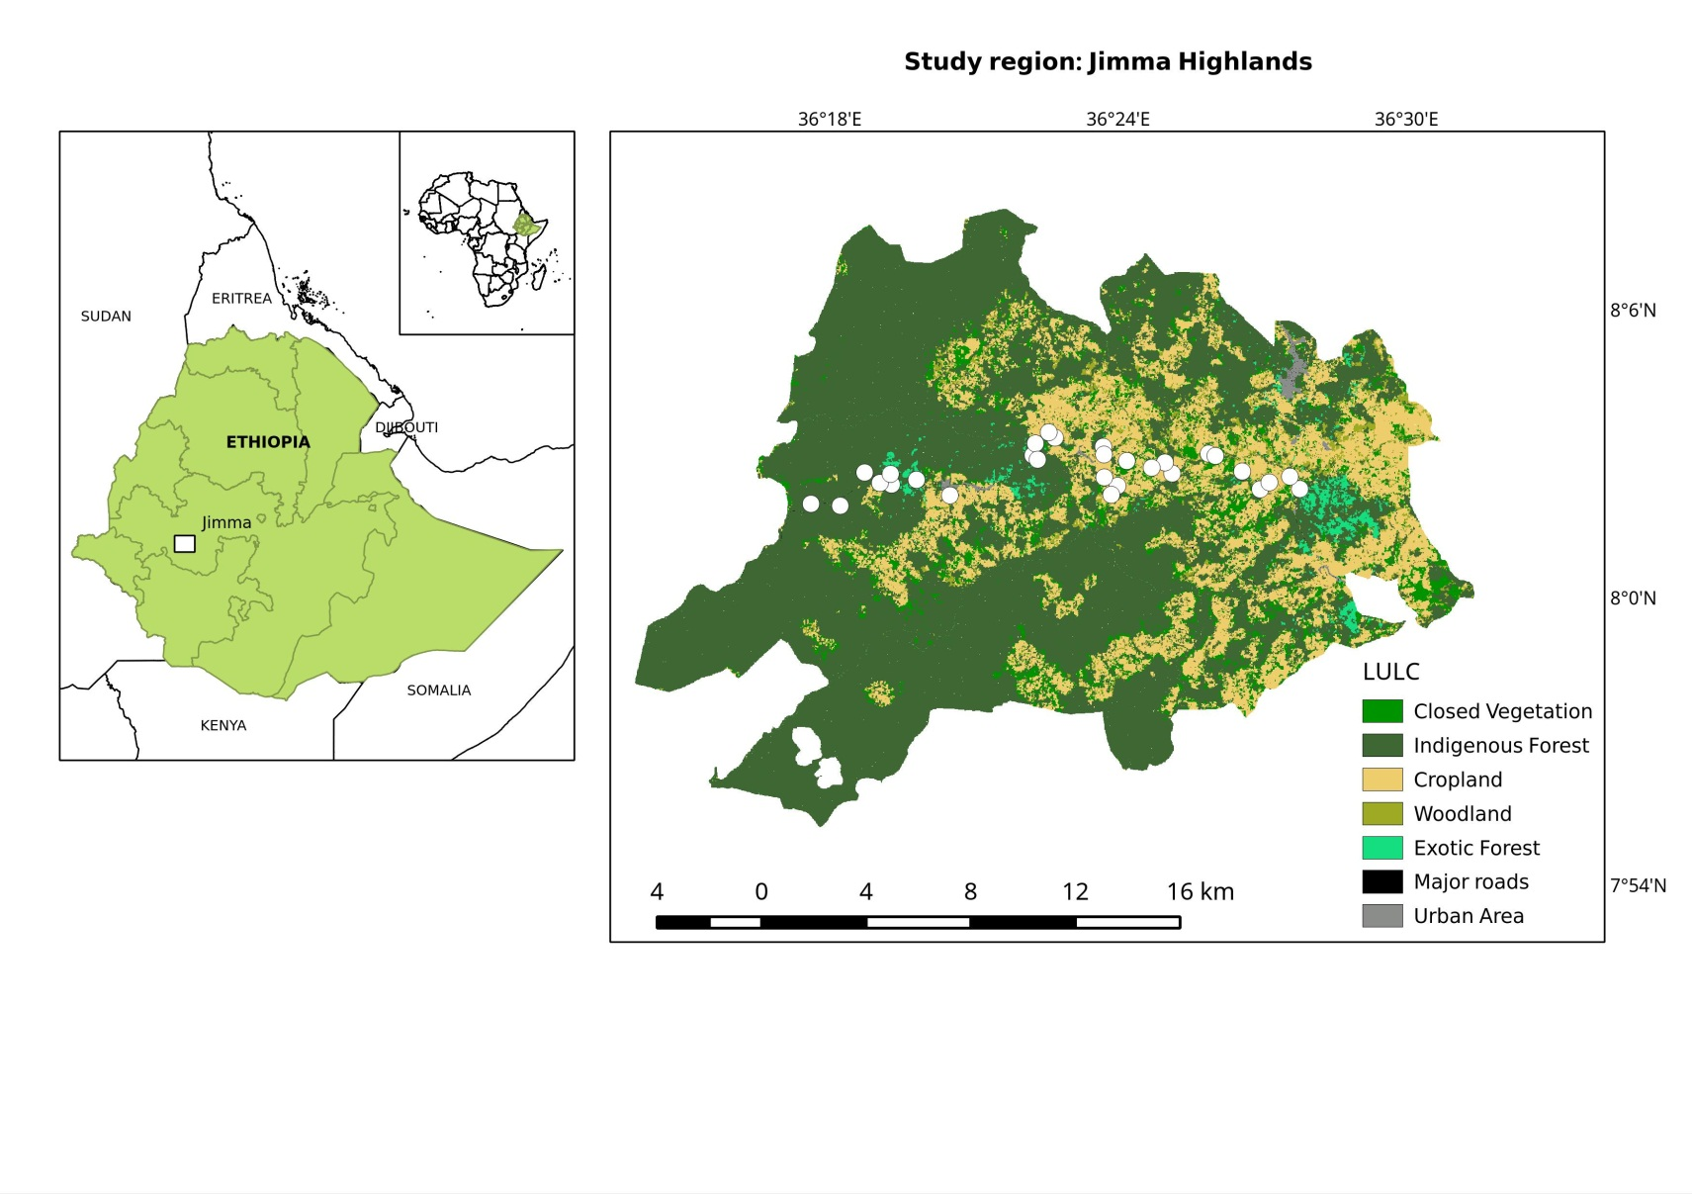

Figure S2. Abundance of sub-families within the six land-use categories. Bars represent mean abundance per plot and error bars represent SEM.

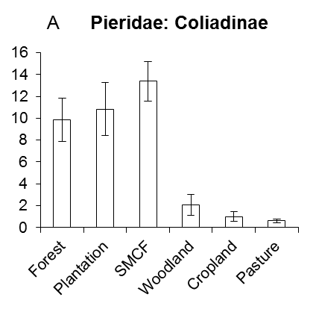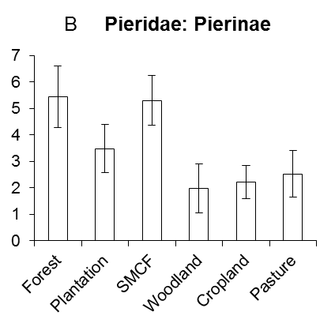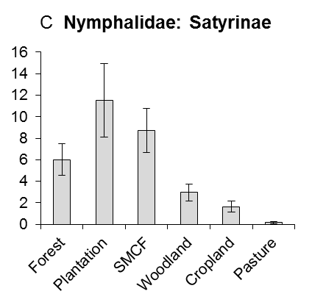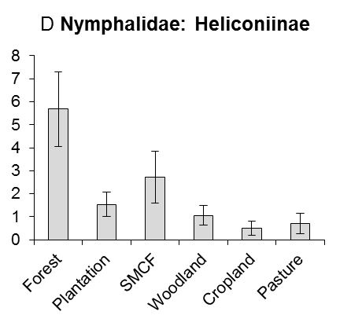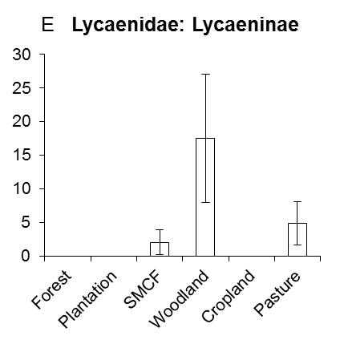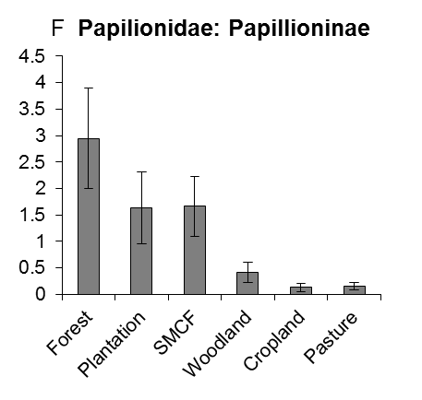

R2GLMM= 0.54

R2GLMM= 0.17

R2GLMM= 0.43

R2GLMM= 0.20

Abundance

Abundance

Abundance

R2GLMM= 0.10

R2GLMM= 0.19

R2GLMM= 0.10

R2GLMM= 0.15

E  **Lycaenidae: Polymmatinae**

Figure S3. Non-metric multidimensional scaling plot illustrating butterfly community structure in relation to land-use. Circles represent butterfly species, with colours indicating their family. Land-use categories: F= natural forest, PLNT= plantation, SMCF= semi-managed coffee forest, W= open woodland, C= cropland and P= pasture.



**F**

**PLNT**

**SMCF**

**W**

**P**

**C**