Real-time Mobile Enabled Scheme for Virtual Spectacle Frame Selection

Md Zakir Hossen; David Chik; Ashim Chakraborty; M A Hossain
Anglia Ruskin IT Research Institute, Anglia Ruskin University, Cambridge, CB1 1PT UK

Abstract—Selection of physical appearance related personal item in online shopping is extremely difficult. This research presents a mobile enabled scheme that provides an advanced online shopping experience of spectacle frames selection. The application is developed to automatically detect the face shape of the user from an image, give suggestions of frames based on the shape, and provide a virtual try-on for the user. Active Shape Model has been used to identify the facial landmark points. Mathematical equations have been designed to analyze and map the landmark points to a face shape. Expert knowledge has been used to recommend frames for each face shape. Haar feature based face and eye detector provided by OpenCV has been used to detect the face and identify the position of eyes for virtual try-on. So far this is the best mobile enabled application for real-time frame selection.
Keywords—Active Shape Model, Face detection, Eye detection, Face Shape, Virtual try-on, Spectacle frame.

Introduction
The emergence of online shopping has brought unprecedented flexibility in shopping by saving time and energy of the consumers. From a multi-user transaction processing computer connected to a television used by the pioneer of online shopping Michael Aldrich [1] to the recent smartphone devices, online shopping has now become a huge platform for retail shopping. According to Centre for Retail Research [2] E-commerce holds the top position among the faster growing retail markets in Europe. M-commerce a commonly referred term for mobile e-commerce which denotes the ability to purchase products using an internet-enabled mobile device. Clarke [3] believes that the increased use of wireless internet devices like the smartphones has created huge opportunities for e-commerce especially M-commerce to take advantage of the benefits of mobility.
However, with the large number of products of different range and quality, shopping experience can sometimes become confusing, especially in the case of selecting spectacle frames. Many people spent a lot of time in a Spectacle shop. It is difficult to narrow down the choices because selecting the most suitable frames can be baffling. Although there are mobile apps that show all the popular frames of luxury brands, to our best knowledge, so far there does not exist any mobile app that can automatically filter the choices based on customer features.
Face shape is one of the key factors for selecting the best spectacle frames (e.g. [9]). There are some web applications that help the users find out their face shape. Birchbox.com [4] asks the users to take up a tape measure and get measurements for their Forehead, Cheekbones, Jawline and Face length. There are some other web applications that takes the same approach which can be confusing and time consuming at once for the users. Sunglasshut.com [5] has a face shape identifier tool where users need to select their gender and then upload a picture of themselves to know their face shape. The algorithm used by Sunglasshut is not publicly available to compare. Being a web application Sunglasshut takes a few moment (around 30 seconds) to complete the process. In this paper, we presented a new solution which is a fast native mobile application. The solution has been designed to identify the face shape from a given frontal image of the user. Active shape model has been used to derive the landmark points on the face which are then mapped to a shape using mathematical equations. Once the face shape is identified, the application suggests suitable spectacle frames to the consumer.
While getting smart suggestions based on face shape can be relieving for the consumer, the consumer may still suffer from indecision regarding how the frames would really look on their face. Our application has therefore added a virtual try-on feature to address this issue. Virtual try-on provides opportunity to the users of computing devices to try on different goods virtually on different objects where the object might be anything from an image of the user himself to a room of the house that he wants to decorate. It can provide great flexibility to the consumers by saving the time and waste of valuable money because they can try on and see how the product would look like on the objects and decide before buying. This shows the huge potential that the virtual try-on platforms hold.
The application has one such virtual try-on feature for the users to try on spectacle frames on their face. There are several web and mobile applications that currently offers this feature to the customers. Ditto [6] is an interactive e-commerce web application. It creates a 3D head model of the user and renders the digitalized spectacle frame on the users face model. The system of Ditto was created by Waupotitsch [7] who had patented this idea of ‘Interactive try-on platform for eyeglasses’. Glasses.com is another example of this technology who uses the same approach for virtual try-on of eyewears in their iPhone application. They need the customers to record a video of the frontal face and put a card on the forehead to create a 3D model, which is not so convenient. In this paper, we take another approach to develop the virtual try-on feature for a real-time decision making for the customers.
The virtual try-on of this application first detects a face from the image and then identifies the position of the eyes. This is done by using OpenCV Haar feature based cascade classifiers [8]. Once the position of the eyes is obtained, the system overlays a transparent image of the selected spectacle on the face.
By combining the technology of Active Shape Model along with OpenCV, the application provides an advanced shopping experience to the customers of spectacle frames by detecting their face shape automatically to suggest frames and a quick virtual try-on to let them see how they would look with their selected spectacles on their face. It offers a great help for them to find out the best spectacles with minimal efforts.
Details of our implementation method will be explained in Section II. Results will be presented in Section III. Finally, discussions will be provided in Section IV.
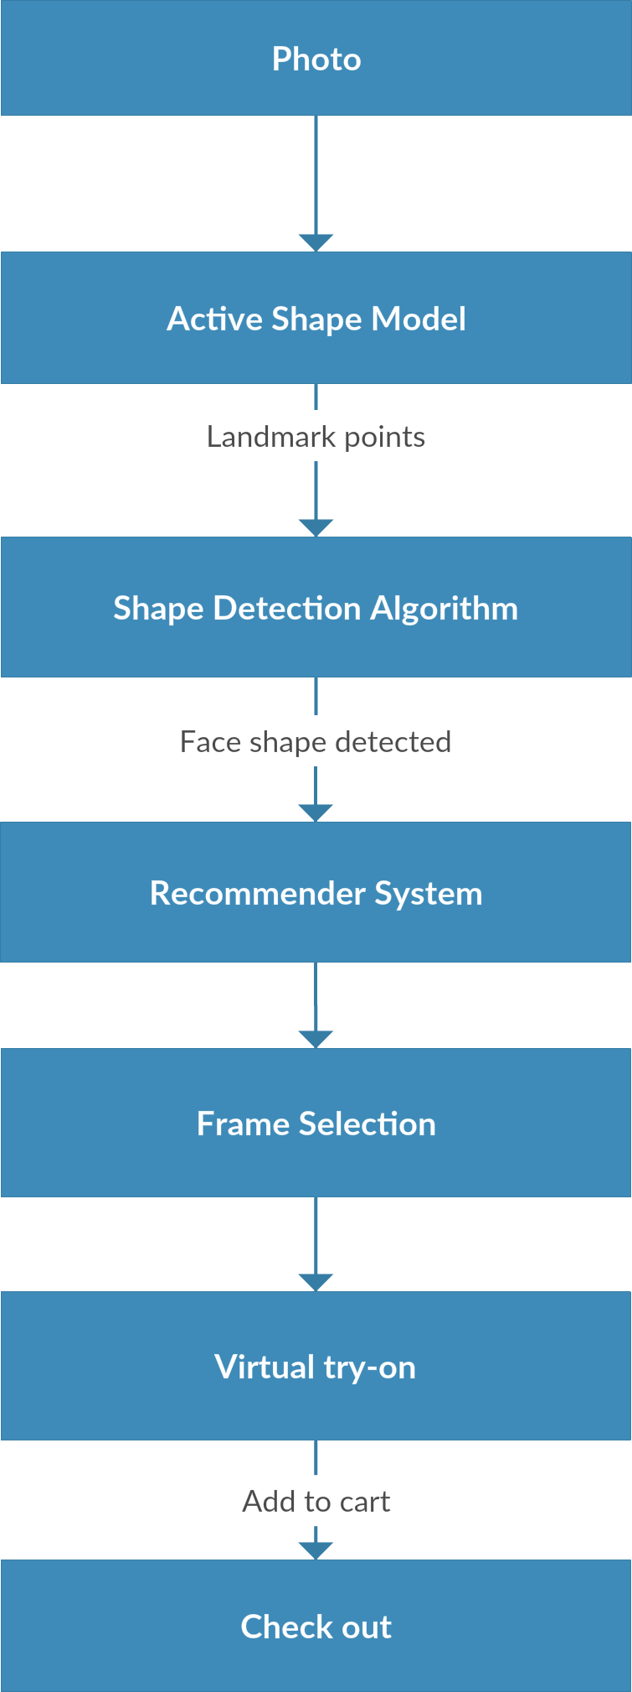
Fig. 1. Flow diagram of the proposed system. The image of the user is processed by the Active Shape Model to obtain the points required for shape identification and later OpenCV haar-feature based detector has been used to detect the face and eye positions in the image for virtual try-on.

Method

Overview of the System
Fig. 1 shows the overview of the system. First, an image of the user is taken from the mobile device camera. Next, OpenCV and Active Shape Model are used to identify the landmark points on the face which are used to determine the face shape of the user (details will be provided in Section B below). Once the face shape is identified by the system, it provides spectacle frame suggestions based on the face shape of the user (details will be provided in Section C). Next, the user selects a frame from the suggestions. Then the user goes onto use the virtual try-on to try on the spectacle (details in Section D). Once the users finalize the spectacles they want to buy, they add them to the cart and check out.

Extraction of Face Shape
According to Morgan [9], face shape is one of the three main points that needs to be considered when selecting spectacle frames. There are different ways to determine the face shape but they all need some efforts and time from the users. This work finds a new solution to identify the face shape automatically from the image given by the user. This module extracts the landmark points of the face from the given image by using OpenCV and a modified Active Shape Model.
Active shape models (ASMs) are basically statistical models of the object shapes which fit in a new image by repeated deforming. Tim Cootes and Chris Taylor [10] suggested this method in which the shapes are constrained by the point distribution model (PDM). PDM is an effective and very strong method of shape description for locating new objects of the shapes in new images. A set of points are used to refer to the shape of an object. New image is matched with the model by the ASM algorithm. Active Shape Models has been found very useful in computer vision and image processing and it is being widely used in these two fields.
In this work we use Stasm, a C++ library for identifying landmark points on the face which is a modified and faster Active Shape Model developed by Milborrow and Nicolls [11]. Milborrow and Nicolls in their work used the Active Shape Model for locating facial landmarks, but for template matching, instead of using the 1D gradient profiles that are used in the classical model, they have used a simplified Scale-invariant feature transform (SIFT) descriptor [12]. SIFT algorithm detects and analyzes the image to describe the local features in it. Additionally, Multivariate Adaptive Regression Splines (MARS) [13] was used to efficiently match these descriptors around the landmark. They have suggested methodologies which led to a noticeable decline in the computational load. This makes this SIFT based ASM useable in practical applications. We use the first 16 landmark points on the face returned by Stasm. Fig. 2 shows a photo of actor Tom Cruise found from the internet (http://yourhairstyles.info/wp-content/uploads/2015/06/ tom-cruise-hairstyle-photos.jpg) with the landmark points drawn on his face.
After extracting the coordinates of landmark points, we decide the face shape according to Fig. 3. This work identifies four basic face shapes which are Square, Round, Oval and Heart. Square and Round faces usually have a wider jawline than that of Oval and Heart shaped faces. Therefore we use the angle between the jawline landmark points to distinguish between the Square/Round and Oval/Heart shaped faces.
To find the jawline angle we take three points a, b and c shown in Fig. 2. These three points together form a triangle. Let us denote the coordinates of point a $(x_{a},y_{a})$; b $(x_{b},y_{b})$; c $(x_{c},y_{c})$. We then derive the length of three sides A (1), B (2) and C (3) of the triangle using the distance formula.

$A=D_{bc}=\sqrt{{(x_{c}- x_{b})}^{2}+{(y_{c}-y_{b})}^{2}}$ (1)
$B=D_{ac}=\sqrt{{(x_{c}- x_{a})}^{2}+{(y_{c}-y_{a})}^{2}}$ (2)
$C=D_{ab}=\sqrt{{(x_{b}- x_{a})}^{2}+{(y_{b}-y_{a})}^{2}}$ (3)
Where $D_{ij}$ denoted the distance between the two points $i$ and$j$. After deriving the three sides A, B and C we use the Law of Cosine (4) to find the jawline angle θ.
$θ= \cos^{-1}\left(\frac{B^{2}+A^{2}-C^{2}}{2AB}\right)$ (4)
We have used 30 photos of celebrities from the internet who have different face shapes, and analyzed the difference between the jawline angles. We have found that Square and Round faces tends to have wider jawline angle than that of Heart and Oval shaped faces. We define a threshold for the jawline angle $T_{jawline}$ to differentiate between them. As shown in Fig. 3, if$θ≤T_{jawline}=159$, then the face shape will be either Heart or Oval; otherwise it will be either Square or Round.
In order to distinguish between Heart and Oval face shape, we consider the cheekbone angle $∅$, which is the angle between points g-to-h and i-to-h. It is derived by the same law of cosine (4). From the celebrity images used in this work it is found that the heart shaped faces have a wider cheekbone angle than Oval face shapes. We define a threshold $T_{cheekbone}$ for cheekbone
angle $∅$. If $∅≤T_{cheekbone}=164,$ then the face shape will be Heart; otherwise it will be Oval.
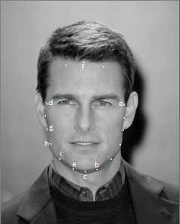
Fig. 2. A photo of actor tom cruise showing the landmark points on his face. This landmark points are obtained using Stasm, a C++ library for a modified Active Shape Model. The photo is taken from http://yourhairstyles.info/wp-content/uploads/2015/06/tom-cruise-hairstyle-photos.jpg.

Finally, in order to distinguish between Round and Square shape, we need to consider the face width (w) and height (h), which are derived from the points d-to-e and f-to-c using the same distance formula. We also consider two diagonal distances between points d-to-b ($D_{db}$) and e-to-a ($D_{ea}$). Then we define another parameter $∆$ using the following equation:
$∆ =(\frac{\frac{D_{db}+D_{ea}}{2}}{\sqrt{{(w}^{2}+h^{2})}})$ (5)
If this parameter$∆ ≤T_{diagonal}= 0.47$, then the face shape will be Round; otherwise it will be Square.

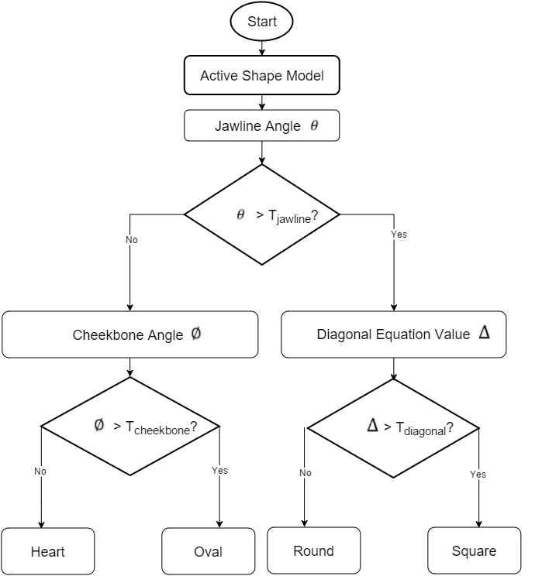

Fig. 3. A flowchart of the algorithm for face shape identification. Active Shape Model gives the landmark points which are then analyzed for determining the jawline angle, cheekbone angle and the diagonal equation for differentiating among the four face shapes.

Recommendation
Once the system identifies the face shape, it provides spectacle frame recommendations to the user by using expert knowledge from Framesdirect.com. We consider 100 frames of 13 different types: rectangle, square, cat-eye, wayfarer, aviator, wrap/shield, oversized, embellished, top-heavy, wide top, boxy, heavy brow and round. The system shows the frames that are more suitable for the identified face shape. We use suggestions for oval [14], heart [15], round [16] and square [17] faces given by framesdirect.com. For oval shaped faces oversized frames are excluded from the recommendations. Round and oversized frames are not suitable for round face shapes. Embelished, top-heavy and wide top frames are omitted while suggesting frames for faces that have a heart shape. Boxy, oval and heavy brow frames are not suggested for the square face shapes.

Virtual Try-on
The application has a virtual try-on feature through which the consumer can try-on various spectacles on their face to decide the most appropriate one. The system uses 2D transparent image of the spectacle frames which are overlaid on the users face.
The positon of the face and eyes on the image of the user is needed to properly fit and overlay the 2D transparent image of the frame. In this work, OpenCV Haar Feature-based Cascade Classifier for frontal face and eyes has been used to identify the face and eye region. The cascade face classifier proposed by Paula Viola and Michael Jones is based on Adaboost algorithm and can quickly and effectively detect faces and other objects.
Once the face is detected and the position of the eyes is determined by the OpenCV classifiers, the system computes the angle between the two eyes to address a tilted face if it is there.
Once the Height, Width and the angle between the eyes are derived, the system uses the measurements to properly overlay the transparent image of the spectacle frame on the face. Considering in mind that the users may want to try-on several spectacles on their face before going to make the final decision the system stores the detected measurements of the face and eyes during the upload of the image so that the try-on is faster for their subsequent uses of the application. Fig. 4 shows the flowchart of the algorithm.
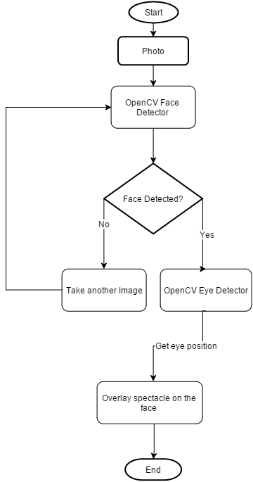
Fig. 4 Flowchart of the virtual try-on algorithm. First a user photo is taken and OpenCV face and eye detector is used to find the face and the position of the eyes. The system then overlays a transparent image of spectacles on the face.

Results
In this paper we have provided some screenshots of the application. Fig. 5 shows the results of our mobile application. First, as shown in Fig. 5a, the user (the first author of this paper) captures a new image using the device camera (it is also possible to upload one from the device gallery). Next, the app automatically gives landmark points (white dots around the edge of the face, as shown in Fig. 5b) and decides a face shape (e.g. Round in this case). After that, the app selects and shows 4 suggested frames from the frame library (Fig. 5c). The user can then use the virtual try-on function to try the preferred frame on his face (Fig. 5d).
The processing time of determining the face shape is around 5 seconds, which is faster than Sunglasshut.com [5]. One possible reason is the fact that we do not need to upload the photo over the internet (in the app the process is local). Sunglasshut.com does not disclose their algorithm, so it is difficult to analyze. However, we think that if Algorithm A runs faster in a mobile device than Algorithm B in the server, then Algorithm A should be considered as more efficient.
The processing time of suggesting frames is less than 1 second. At the current stage, there are 100 frames in the library. More will be added in future.
The processing time of virtual try-on is around 5 seconds. To analyze the performance of our face shape identifier algorithm, we tested images of celebrities with known face shapes that are considered for this work. We use celebrity example of different face shapes given by Jessica [18] and Jessica [19]. For our analysis we have used 16 frontal face images of 8 celebrities who have different face shapes with clear view of the jawline and cheekbone. Out of those 16, our algorithm correctly identified the shape from 13 photos. Performance of the algorithm highly depends on how accurately the landmark points are identified by the ASM. Some of the celebrity faces used were slightly tilted or didn’t have a neutral expression which led to a less accurate landmark determination by the ASM. Considering these limitations our algorithm still did reasonably well to determine the face shape. We are still working to improve the performance further.

Fig. 5a Screenshot of the developed application showing an image of the user uploaded from the device gallery.

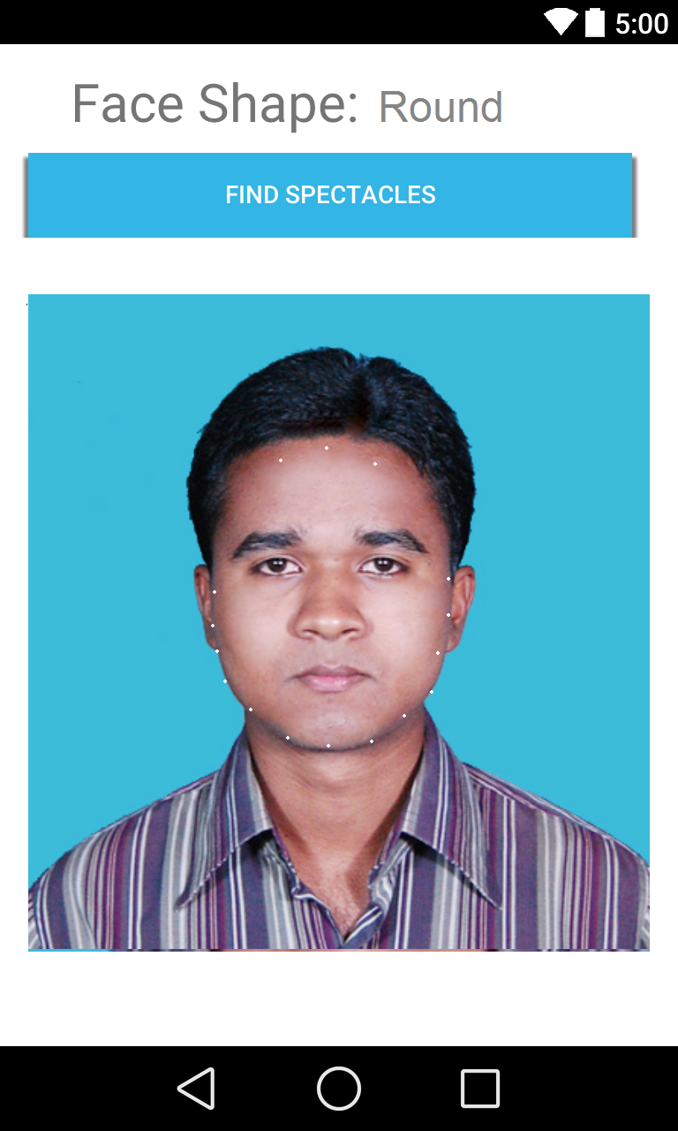
Fig. 5b Screenshot of the application showing the landmark points on the face with identified face shape shown on top of it.

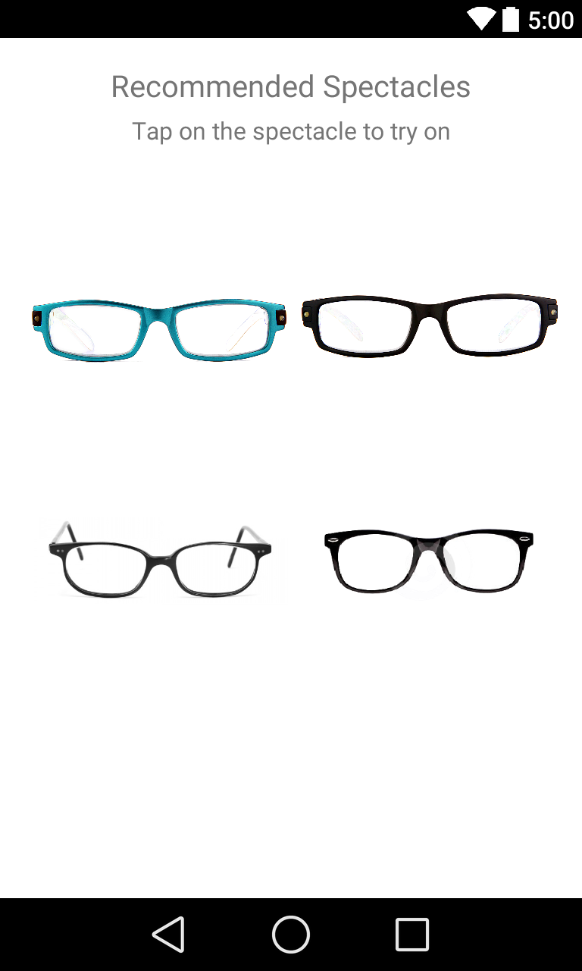
Fig. 5c Application recommends some frames based on the users face shape.

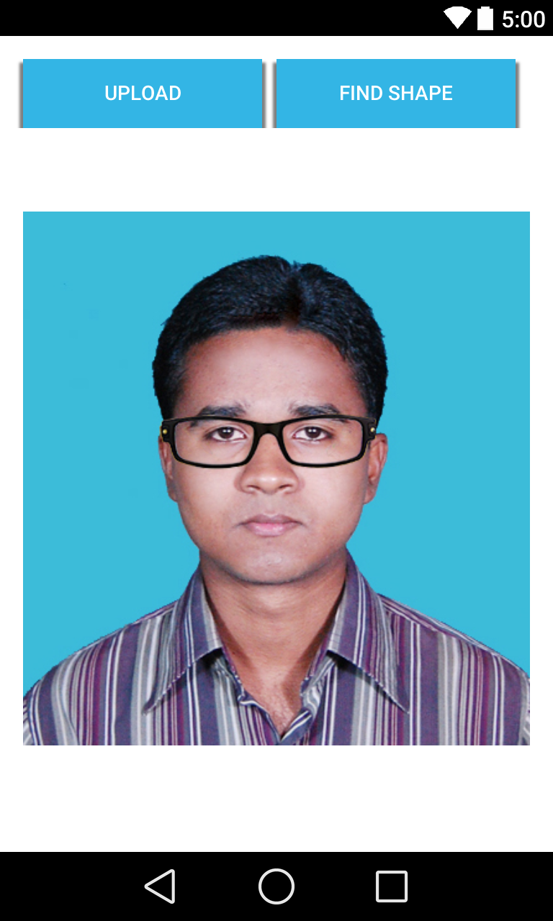
Fig. 5d User using the virtual try-on to try his preferred frame on his face.

Discussions
In this work we have demonstrated a user friendly and intuitive mobile application developed for android platform to provide a satisfactory, comfortable and faster shopping experience for spectacle frames. The application identifies the face shape from an image and provides frames that are most appropriate for that particular shape.
Although there are arguably more face shapes among the people, this work currently identifies four basic and most acknowledged face shapes. One of the limitations of the approach we have used here is that the accuracy of the shape identifier algorithm which depends highly on the accurate information obtained from the active shape model. Further work will be carried out to increase the accuracy of the algorithm and add capabilities to identify more face shapes.
At the current stage, frame recommendation is based on expert knowledge from FramesDirect.com as there is no publicly available and reliable data sets for applying machine learning based recommendations for spectacles. In future, we would like to develop a learning algorithm that will learn the preferences of the majority from a large number of users having the similar set of facial features, gender and skin tone. In addition, the app will also provide options such as brand and price.
We used a simple and easier approach for virtual try-on for minimal user interaction. We intend to add a 3D model based try-on feature in the application without compromising on the performance in future to further enhance the shopping experience.
We would like to continue our work and improve our algorithm for more accurate and satisfactory performance. Hence the future work will be concentrated on better algorithm for extracting face shape, introducing machine learning based frame recommender system, and a 3D virtual try-on. Once ready the application will be available for public to download and use. Hopefully people will enjoy their shopping experience through this application.

Acknowledgment
This work is supported by the EU funded FUSION Project under Anglia Ruskin IT Research Institute.

References
- Aldricharchive.com. The Michael Aldrich Archive - Internet Online Shopping [Internet]. 2015 [cited 9 September 2015]. Available from: http://www.aldricharchive.com/internet_online_shopping.html
- Retailresearch.org. Online Retailing: Britain, Europe, US and Canada 2015 [Internet]. 2015 [cited 1 September 2015]. Available from: http://www.retailresearch.org/onlineretailing.php
- Clarke, I. “Emerging value propositions for M-commerce,” Journal of Business Strategies(18:2), 2001, p. 133 – 148.
- Birchbox United States. How to Determine Your Face Shape [Internet]. 2015 [cited 30 August 2015]. Available from: https://www.birchbox.com/guide/article/how-to-determine-face-shape-men
- Sunglasshut.com. Shop by Face Shape | Sunglass Hut [Internet]. 2015 [cited 9 September 2015]. Available from: http://www.sunglasshut.com/us/sunglasses-trends/shop-by-face-shape
- try-on S. DITTO: Secret's out on our 3D virtual try-on [Internet]. Blog.ditto.com. 2013 [cited 2 September 2015]. Available from: http://blog.ditto.com/2013/10/our-secrets-out-how-our-cutting-edge.html
- Waupotitsch R, Tsoupko-Sitnikov M, G. Medioni G, Mishin O, Shamgin V, Callari F et al. Interactive try-on platform for eyeglasses. US7016824 B2, 2006.
- Viola, P.; Jones, M., "Rapid object detection using a boosted cascade of simple features," in Computer Vision and Pattern Recognition, 2001. CVPR 2001. Proceedings of the 2001 IEEE Computer Society Conference on , vol.1, no., pp.I-511-I-518 vol.1, 2001
- Morgan E. How to Choose the Best Eyeglasses for Your Face Shape and Coloring [Internet]. All About Vision. 2015 [cited 9 September 2015]. Available from: http://www.allaboutvision.com/eyeglasses/eyeglasses_shape_color_analysis.htm
- Cootes, T. F., Taylor, C. J., Cooper, D. H., and Graham, J. Active Shape Models — their Training and Application. CVIU, 1995.
- Milborrow S, Nicolls F. Active Shape Models with SIFT Descriptors and MARS. VISAPP. 2014;
- Lowe, D.G., "Object recognition from local scale-invariant features," in Computer Vision, 1999. The Proceedings of the Seventh IEEE International Conference on , vol.2, no., pp.1150-1157 vol.2, 1999
- Friedman, Jerome H. Multivariate Adaptive Regression Splines. Ann. Statist. 19, no. 1, 1--67. doi:10.1214/aos/1176347963. http://projecteuclid.org/euclid.aos/1176347963, 1991.
- FramesDirect.com. Online Glasses Guide - Oval Faces: Find the Best Frames for Your Shape [Internet]. 2015 [cited 9 September 2015]. Available from: http://www.framesdirect.com/landing/a/face-shape-guide-oval.html
- FramesDirect.com. Online Glasses Guide - Heart Faces: Get the Best Frames for Your Shape [Internet]. 2015 [cited 3 September 2015]. Available from: http://www.framesdirect.com/landing/a/face-shape-guide-heart.html
- FramesDirect.com. Round Faces Online Glasses Guide: Find the Best Frames for Your Shape [Internet]. 2015 [cited 19 August 2015]. Available from: http://www.framesdirect.com/landing/a/face-shape-guide-round.html
- FramesDirect.com. Square Faces Online Glasses Guide: Find the Best Frames for Your Shape [Internet]. 2015 [cited 9 September 2015]. Available from: http://www.framesdirect.com/landing/a/face-shape-guide-square.html
- Jessica D., Glamourmagazine.co.uk. Celeb Face Shapes [Internet]. 2015 [cited 9 September 2015]. Available from: http://www.glamourmagazine.co.uk/beauty/celebrity/hair/2009/01/08/celebrity-hairstyles-and-face-shapes/viewgallery/345456
- Jessica C,. How to Find Your Face Shape [Internet]. POPSUGAR Beauty UK. 2013 [cited 9 September 2015]. Available from: http://www.popsugar.co.uk/beauty/What-Your-Face-Shape-30583215

