Effect of non-cross-linked calcium on characteristics, swelling behaviour, drug release and mucoadhesiveness of calcium alginate beads

Adnan Al Dalatyª, Ayman Karam^{b}, Mohammad Najlah^{c}, Raid G. Alany^{d,e} and Mouhamad Khoder^{a,d}*
ª University Al Baath, Faculty of Pharmacy, Homs, Syria
^{b} Institut de Chimie des Milieux et Matériaux de Poitiers, CNRS, Université de Poitiers/ENSIP, 1 rue Marcel Doré, 86073 Poitiers Cedex, France
^{c} Faculty of Medical Science, Anglia Ruskin University, Bishops Hall Lane, Chelmsford
CM1 1SQ, United Kingdom
^{d} School of Pharmacy and Chemistry, Faculty of Science, Engineering and Computing
Kingston University, London, Penrhyn Road, Kingston upon Thames, KT1 2EE Surrey, United Kingdom.
^{e} School of Pharmacy, The University of Auckland, Auckland, New Zealand

*Corresponding author
Mouhamad Khoder, Ph.D.
School of Pharmacy and Chemistry
Faculty of Science, Engineering and Computing
Kingston University London
Penrhyn Road, Kingston upon Thames,
KT1 2EE Surrey, UK.
e-mail: m.khoder@kingston.ac.uk

ABSTRACT
In this study, ibuprofen-loaded calcium alginate beads (CABs) with varying amounts of non-cross-linked calcium (NCL-Ca) were prepared using different washing methods. The influence of NCL-Ca on beads properties was investigated. Increasing the number or duration of washes led to significant decreases in the amount of NCL-Ca whereas the impact of the volume of washes was not significant. Approximately 70% of the initial amount of Ca⁺² was NCL-Ca which was removable by washing while only 30% was cross-linked (CL-Ca). Ca⁺² release from the CABs was bimodal; NCL-Ca was burst-released followed by a slower release of CL-Ca. Washing methods and the amount of NCL-Ca had significant influences on the encapsulation efficiency, beads weight, beads swelling, drug release profile and the mucoadhesiveness of CABs. This study highlighted the importance of washing methods and the amount of NCL-Ca to establish CABs properties and understand their behaviour in the simulated intestinal fluids (SIFs).

Keywords: Calcium alginate beads, cross-linked calcium, non-cross-linked calcium, encapsulation efficiency, mucoadhesiveness, drug release.

1. Introduction

Alginates are natural, nontoxic and biodegradable polysaccharide polymers available in abundance from renewable sources (Tonnesen & Karlsen, 2002). Alginates form gel under mild environment in the presence of divalent cations such as Zn⁺² or Ca⁺² without the need for toxic reactants. Furthermore, alginates display very good muco- and bioadhesive properties prolonging their residence time in different mucosal tissues (Sosnik, 2014). Due to their unique properties and the gelation simplicity, alginates have been widely used in many pharmaceutical applications such as the development of mucoadhesive and controlled release delivery systems for drugs and proteins (Alipour, Montaseri & Tafaghodi, 2010, Azarnia, Lee, Robert & Champagne, 2008, Barzegar-Jalaliet al., 2013, Gray & Dowsett, 1988, Iskenderoglu, Acarturk, Erdogan & Bardakci, 2013, Jamstorp, Bodin, Gatenholm, Jeppsson & Stromme, 2010, Yanget al., 2013), the immobilization/encapsulation of cells for tissue engineering applications (Singh, Deol & Kaur, 2012, Xu, Xu, Wang, Ye, Zhou & Tan, 2014) and the bone regenerative medicine (Schutz, Despang, Lode & Gelinsky, 2014).
Alginates are composed of 1–4 linked α-l-guluronic acid (G) and β-d-mannuronic acid (M) arranged alternately in homopolymeric blocks (poly-M and poly-G) and in mixed blocks (MG). The poly-G and the MG blocks are buckled while the poly-M blocks have a shape referred to as an extended ribbon (Giri, Thakur, Alexander, Ajazuddin, Badwaik & Tripathi, 2012, Sriamornsak, Thirawong & Korkerd, 2007). The cavities formed between two adjacent guluronates in the poly-G or MG blocks are of dimensions that are ideal for the cooperative binding of Ca⁺² (George & Abraham, 2006). When a solution of sodium alginate is extruded into a solution of calcium chloride, Ca⁺² diffuses into the alginate droplets. This causes the gelation of alginate and eventually the formation of CABs. Whilst in the cavities among the guluronates, Ca⁺² cross-link with poly-G and/or MG blocks generating a gel with a characteristic structure known as an egg-box structure (Donati, Holtan, Morch, Borgogna, Dentini & Skjak-Braek, 2005, Morch, Donati, Strand & Skjak-Braek, 2006, Sriamornsak & Kennedy, 2008). Poly-M does not contribute to cross-linking with divalent ions (Morch, Donati, Strand & Skjak-Braek, 2006). Thus, the composition and block structure of alginates have an essential influence on both its gelation and ion-binding properties (Morch, Donati, Strand & Skjak-Braek, 2006).
Rich in guluronate residues, CABs have a higher extent of cross-linking and a lower release rate of encapsulated drug compared to that of fewer guluronate residues (Fathy, Safwat, el-Shanawany, Shawky Tous & Otagiri, 1998, Sriamornsak & Kennedy, 2006). The extent of alginate cross-linking is also influenced by the concentration of the cross-linker solution and the curing time (Tateshita, Sugawara, Imai & Otagiri, 1993). In general, the higher the concentration of Ca⁺² solution and/or the longer the duration of cross-linking process the greater is the extent of cross-linking, hence, slower drug release (Heng, Chan & Wong, 2003, Rajinikanth, Sankar & Mishra, 2003). The composition of the in vitro release testing medium may also have a significant effect on the rate of drug release (Assifaoui, Chambin & Cayot, 2011). For example, release mediums containing chelating agents such as phosphate salts or high concentration of monovalent ions displace the cross-linkers, destabilize the beads and accelerate the drug release (Kim, Chung, Shin, Yam & Chung, 2008).
The Ca⁺² retained by CABs can be either CL-Ca which is tightly cross-linked with poly-G and MG blocks or NCL-Ca having a weak interaction with the poly-M blocks (Bourgeois, Gernet, Pradeau, Andremont & Fattal, 2006, Khoder, Tsapis, Huguet, Besnard, Gueutin & Fattal, 2009, Kikuchi, Kawabuchi, Watanabe, Sugihara, Sakurai & Okano, 1999). NCL-Ca is normally removable by a washing process whereas the CL-Ca is not washable (Bourgeois, Gernet, Pradeau, Andremont & Fattal, 2006, Khoder, Tsapis, Huguet, Besnard, Gueutin & Fattal, 2009). It is noteworthy that although the washing methods are of great importance during the preparation of CABs, there have been very little about it in literature. Furthermore, the influence of the NCL-Ca on the properties of CABs and the rate of drug release has not yet been profoundly investigated. Similarly, the influence of SIFs on the beads Ca⁺² content and subsequently on the drug release profile has not been adequately studied.

In this study, the preparation and characterisation of CABs containing different amount of NCL-Ca are described. The impact of washing procedures on CABs properties is investigated. And, to establish a validated method for drug release from CABs, beads mucoadhesiveness, beads swelling behaviour and drug release profile are studied in two different simulated intestinal fluids.
2. Materials and methods
2.1. Materials
Sodium alginate extracted from Laminaria hyperborea with a MW of 1.97×105 and M/G ratio of 0.59 was purchased from BDH Chemicals Limited, UK. Ibuprofen (IBU), calcium chloride (CaCl₂), eriochrome black T and ethylenediaminetetraacetic acid (EDTA) were supplied by Sigma-Aldrich, UK. Water was purified using automatic water still (SAWS-1008 Shin saeng scientific co. ltd, Korea).
In order to investigate the impact of the composition of dissolution medium on the swelling and drug release behaviours from CABs, two different simulated intestinal fluids were freshly prepared as following:
- Simulated intestinal fluid based on phosphate buffer (SIFp): contained 99.93 mmol KH₂PO₄ and 27.8 mmol NaOH. The pH was finally adjusted to 6.8 with NaOH 1 M.
- Simulated intestinal fluid based on maleate buffer (SIFm): 19.01 mmol Maleic acid, 34.8 mmol NaOH and 68.69 mmol NaCl. The pH was adjusted to 6.8 with NaOH 1 M.
2.2. Preparation of CABs
CABs loaded with IBU were prepared by ionotropic gelation using CaCl₂ as a cross-linker. Briefly, 3 g of SA was dissolved in 100 mL of deionized water and 2 g of IBU were dispersed in the alginate solution and homogenously mixed. Six (6) mL of the resulting bubble-free dispersion was then dropped using a pump-connected syringe into 60 mL of 10% w/v CaCl₂ solution kept under a gentle agitation. Beads were allowed to stand in CaCl₂ solution for 30 min before being collected and washed. Washing process involved soaking the freshly prepared beads in deionized water with magnetic stirring at 300 rpm. Three washing protocols where adopted; (i) beads were washed for a minute in 60 mL deionised water and the number of washes was increased from 0 to 8 times. Formulations obtained by this protocol were named according to the number of washings (N1, N2, N3, N4, N5, N6, N7 and N8). In the second protocol, (ii) beads were washed one time in 60 mL deionised water for 1, 4 or 8 minutes. In the third, (iii) beads were washed one time for one minute in 60, 120 or 180 mL deionised water. All collected beads were finally dried in an air convection type oven (Memmert, Germany) at a temperature of 40°C for 48h (Khoder, Tsapis, Domergue-Dupont, Gueutin & Fattal, 2010, Sriamornsak & Kennedy, 2006)

2.3. Weight uniformity testing
To determine beads average weight, 20 beads were randomly sampled and accurately weighed using Precisa scale 320 XB balance (220A, Switzerland). The results were expressed as mean values ± standard deviation of 20 determinations.

2.4. Encapsulation efficiency (EE)
Five beads were placed in a beaker containing 100 mL of the SIFm for 48h to allow their complete dissolution. Samples were then taken, filtered and the amount of released IBU was analysed by UV spectroscopy (SP-3000 Plus, Optima, Japan) at 264 nm. The EE was determined according to the formula:
$EE= \frac{Mm}{Mi}×100$
where $Mm$ is the amount of drug measured in five dried beads and $Mi$ is the initial amount of drug dispersed in the alginate solution required to form five beads.

2.5. Scanning electron microscopy
Scanning electron microscopy (SEM) images of the typical external structure of the dried beads N1 before and after their incubation for 2h in either SIFm or SIFp were obtained using FEI Quanta 200 microscope (FEI company, Hillsboro, OR, USA) operated at an accelerating voltage of 30 kV under low-vacuum mode.

2.6. Fourier transform infrared analysis
Fourier Transform Infrared (FT-IR) measurements of SA, IBU and IBU-loaded CABs were performed using an FT-IR spectrometer (Thermo Scientific Nicolet 128 is5, Thermo fisher, Madison, USA). The spectra were acquired over the wavenumber range of 4000 to 500 cm⁻¹ at ambient temperature.

2.7. X-ray diffraction
The precipitate created during the swelling and dissolution studies in SIFp was collected, washed three times with deionized water and dried at 105°C for 5h. The precipitate was then exanimated by X-ray diffraction through Bruker SMART CCD area-detector diffractometer (Bruker AXS, Germany).

2.8. Determination of Ca⁺² content
To determine the total amount of Ca⁺² retained by beads, five beads were weighed and placed in a beaker containing 100 mL of SIFm. After 48h, samples were taken and the amount of Ca⁺² was determined by the complexometric titration method using EDTA solution and eriochrome black–T indicator (Lindstrom & Diehl, 1960). The same method was adopted to determine the release kinetics of Ca⁺² from CABs N1 and N7 in SIFm. The amount of released Ca⁺² was determined at time intervals of (5, 10, 15, 30, 60 and 120 min).

2.9. Beads swelling and drug release studies
Swelling and release studies were carried out on the CABs N1 and N7 in both SIFm and SIFp using a USP rotating basket apparatus (ERWEKA DT 600 HH, Germany) at 100 rpm and 37°C. In each experiment, 40 beads were weighed and placed in the apparatus vessel containing 400 mL of the swelling or the dissolution medium. For the swelling study, beads were carefully taken out at time intervals, drained with filter paper to remove excess water and weighted. Weight changes were calculated using the following equation:
$$\% weight change=\frac{Wt-Wd}{Wd} ×100$$
Where Wt is the weight of beads at a tested time and Wd is the weight of dry beads.
In a separate experiment, samples of tested medium were withdrawn at the same time intervals, filtered and the released amount of IBU was determined by UV spectroscopy (SP-3000 Plus, Optima) at 264 nm.

2.10. Mucoadhesion testing
The mucoadhesiveness of the CABs N1 and N7 in the SIFm were evaluated by in vitro wash-off method (Lehr, Bouwstra, Schacht & Junginger, 1992, Prajapati, Tripathi, Ubaidulla & Anand, 2008). Briefly, freshly excised pieces of sheep intestinal mucosa (2 cm × 2 cm) collected from a slaughter house were mounted on glass slides (7.5 × 2.5 cm) using thread. 25 beads were spread onto each wet piece of mucosa and immediately hung onto the arm of a USP tablet disintegration tester. The tissue specimens were given regular up and down movements in a vessel containing 900 mL of SIFm kept at 37°C. At hourly intervals up to 4 hours, the machine was stopped and the number of beads still adhering onto the tissue was counted. Percent mucoadhesion was given by the following formula.
% adhesive strength = (no. of beads remains / no. of applied microspheres) ×100
2.11. Statistical analysis
Statistical significance was measured using the one-way analysis of variance (ANOVA) and student’s t-tests as appropriate. All values were expressed as the mean ± standard deviation. Values of P < 0.05 were regarded as significantly different.

3. Results and discussion
3.1. Preparation of CABs
IBU-loaded CABs were prepared by ionotropic gelation method. All formulations were allowed to develop the same extent of cross-linking by fixing the polymer/drug ratio at (3:2), the concentration of CaCl₂ solution at (10% w/v) and the cross-linking time at (30 min). According to Sriamornsak et al (2008), 20 minutes is the minimum time needed for complete beads formation by ionotropic gelation. The concentration of CaCl₂ solution used in this study (10% w/v ~ 0.9 M) is considerably higher than the minimum concentration of counter ions needed to form beads which is in the low millimolar range (Chuehet al., 2010). This high concentration of cross-linker solution was used in order to allow a high degree of cross-linking as well as high entrapment of NCL-Ca. Before the drying step, the fresh beads were washed using different washing protocols; hypothetically, varying washing protocols might remove different amounts of NCL-Ca from the beads whereas CL-Ca is not removable by washing processes (Bourgeois, Gernet, Pradeau, Andremont & Fattal, 2006, Khoder, Tsapis, Huguet, Besnard, Gueutin & Fattal, 2009). Therefore, the obtained beads should have the same extent of cross-linking but different amount of NCL-Ca.
Obtained beads were spherical and homogenous regardless of the washing method (Fig. 1a). Scanning electron micrographs of CABs N1 showed relatively rough surfaces with few small crystals probably due to partially crystallized IBU formed during the drying step (Fig. 1b). This hypothesis is supported by the high encapsulation efficiency (93.3%) (Fig. 4a) and by the disappearance of these crystals after 2 h of incubation in the SIFm (Fig. 1c); corresponding to the release of 30% of the loaded IBU (Fig. 5d).
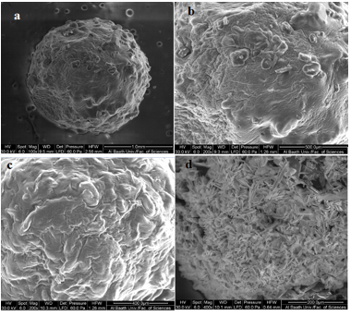
Fig.1. SEM images of (a) dried IBU-loaded CABs N1 (scale bar = 1 mm), (b) the surface of IBU-loaded CABs N1 (scale bar = 500 µm), (c) the surface IBU-loaded CABs N1 after 2 h of incubation in SIFm (scale bar = 400 µm) and (d) the surface IBU-loaded CABs N1 after 2 h of incubation in SIFp (scale bar = 200 µm). X-ray diffractogram of the precipitates formed on the surface of CABs N1 in the SIFp.

3.2. FTIR spectroscopy
Fig. 2 shows the FTIR spectra of SA, IBU and IBU-loaded CABs N1. FTIR spectrum of SA shows a wide absorption bands at 3255 cm⁻¹ indicating the stretching of O−H and sharp absorption bands at 1595, 1405 and 1025 cm⁻¹ representing COO− (asymmetric), COO− (symmetric) and C−O−C, respectively (Fig. 2A). FTIR spectrum of IBU demonstrates characteristic peaks at 1708 cm‐1 and 2920 cm‐1 (Fig. 2B), representing the carbonyl and hydroxyl stretching respectively. Similar spectra of SA and IBU have been previously reported (Jabeen, Chat, Maswal, Ashraf, Rather & Dar, 2015, Setty, Sahoo & Sa, 2005, Velascoet al., 2011). IBU-loaded CAB spectrum shows almost the same characteristic bands observed in the spectrum of free IBU (Fig. 2C). These results confirm that the IBU did not undergo any chemical reaction during the beads preparation. Additionally, the absorption region of stretching vibrations of O–H bonds of alginate in CABs appeared narrower and smaller than that of SA (Fig. 2C and 2A). Daemi and Barikani (2012) observed a similar difference in calcium alginate nanoparticles. They attributed this difference to the participation of hydroxyl and carboxylate groups of alginate with Ca⁺² in the formation of egg-box structure and a consequent decrease in hydrogen bonding between hydroxyl functional groups; this affords a narrow O–H stretching band in calcium alginate (Daemi & Barikani, 2012). Similarly, the intensity of alginate peaks corresponding to COO− (asymmetric and symmetric) and C−O−C decreased significantly after their crosslinking with Ca⁺². This might be attributed to the low percentage ion-bonding of Ca⁺² relative to Na⁺ (Papageorgiou, Katsaros, Kouvelos, Nolan, Le Deit & Kanellopoulos, 2006).
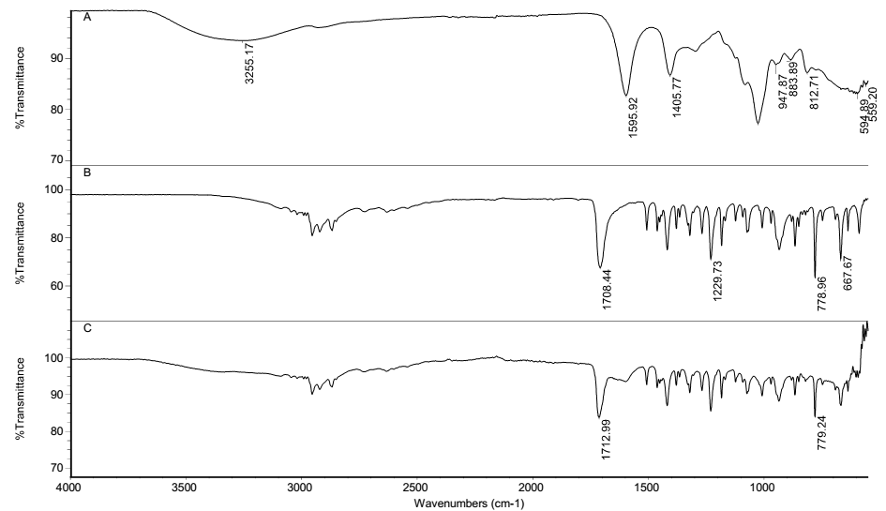
Fig. 2. FTIR spectra of (A) SA, (B) IBU, and (C) IBU-loaded CABs N1.

3.3. Determination of the amount of Ca⁺² retained by beads
Fig. 3 shows that increasing the number and the duration of washes had a significant influence on beads Ca⁺² content (Fig. 3a and 3b). However, the impact of increasing the volume of washes was less significant (Fig. 3c). Interestingly, increasing the number of washes was able to remove an additional amount of Ca⁺² until the sixth wash (P < 0.05). Afterward, washing had no significant impact on the amount of Ca⁺² (Fig. 3a). This result indicates that the Ca⁺² remained within the beads after the sixth wash was already cross-linked, i.e. non-washable CL-Ca. Accordingly, approximately 70% of the initial Ca⁺² content is NCL-Ca and less than 30% is CL-Ca, i.e. all Ca⁺² retained in beads N7, N6 and N8 (Fig. 3a). To confirm these results, the release kinetic of Ca⁺² from beads was also studied (Fig. 3d and 3e). According to Kikuchi et al and others, Ca⁺² release from CABs was bimodal; NCL-Ca is firstly released followed by the release of CL-Ca (Alvarez-Lorenzo, Blanco-Fernandez, Puga & Concheiro, 2013, Kikuchi, Kawabuchi, Watanabe, Sugihara, Sakurai & Okano, 1999). Similarly, Fig. 3 shows that Ca⁺² release from CABs N1 was bimodal with the first phase releasing approximately 75% of total Ca⁺² (Fig. 3d). On the other hand, the release profile of Ca⁺² from CABs N7 was monomodal (Fig. 3e), which is expected according to Fig. 4a as all Ca⁺² remained in the beads N7 are cross-linked.
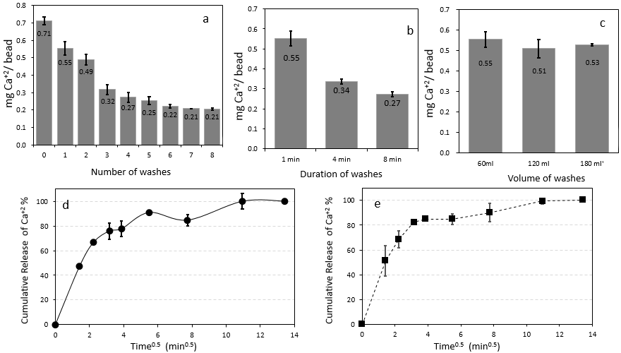
Fig. 3. Ca⁺² content in CABs (mg Ca / bead) as a function of (a) number, (b) duration and (c) volume of washes (n=3 ± SD). Figures (d) and (e) represent the cumulative release of Ca⁺² plotted against the square root of time from CABs N1 in SIFm and in SIFm respectively (n=3 ± SD).

3.4. Encapsulation efficiency (EE)
The EE is significantly affected by the washing process (Fig. 4a and 4b). As washing increases in term of number and duration, an additional and significant amount (p < 0.05) of loaded drug is removed from the beads. Since the loaded drug did not undergo any chemical covalent linking inside the beads (IR results), the amount of encapsulated IBU was descending during the 8 washes. On the other hand, the impact of the washing volume on the EE was less significant (p > 0.05) (data not shown); this is probably due to the sink conditions being attained with the smallest volume of washing (i.e. 60 mL).
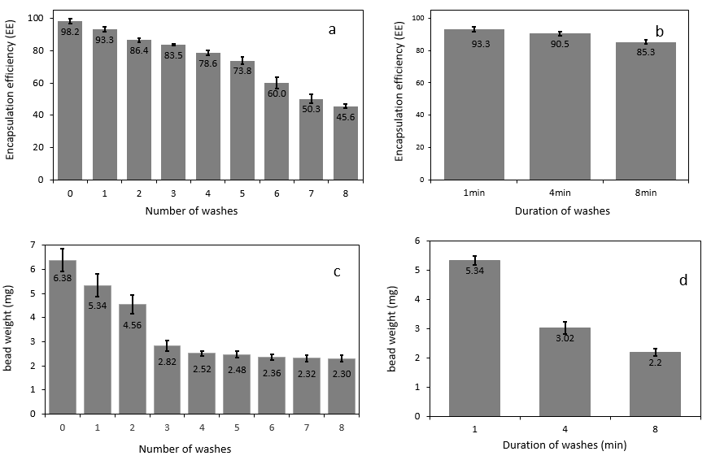
Fig. 4. Encapsulation efficiency of IBU in CABs as a function of (a) number and (b) duration of washes (n=3 ± SD). Figures (c) and (d) represent the average weight of dry CABs as a function of number and duration of washes respectively (n=3 ± SD).

3.5. Impact of the NCL-Ca on the weights of dry beads
The washing process and the amount of NCL-Ca retained by beads have a significant impact on the weight of dry CABs. As shown in Fig. 4, beads weight decreased significantly as the number and the duration of washes increased (P < 0.05) (Fig. 4c and 4d). In contrast, increasing the volume of washes had a less significant effect on beads weight especially when the volume of washing exceeded 120 mL (data not shown). Interestingly, the changes in beads weight were consistent with Ca⁺² content results; this might be explained by the hygroscopic properties of the Ca⁺² which led to the corresponding increases in the water contents of the beads.

3.6. Impact of NCL-Ca on the beads swelling in SIFs
Fig. 5 shows the swelling profile of the beads N1 and N7 in the SIFp (Fig. 5a) and SIFm (Fig. 5b). In both media, CABs N7 swelled more than CABs N1. However, each bead showed dissimilar swelling profiles in both media. For example, beads N7 swelled twice as much in the SIFp (3800% after 240 min) compared with the SIFm (1915% after 240 min). In contrast, the swelling extent of CABs N1 was significantly lower in the SIFp than that in the SIFm. Swelling process lasted 6 h for SIFm and 4 h for SIFp after which the beads started to lose their integrity and overall weight. Accordingly, SEM shows a formation of condense layer of crystals on the surface of CABs N1 (dried after incubation of 2 h in SIFp) (Fig. 1d), whereas no crystals were observed after incubating the same beads for the same time in the SIFm (Fig. 1c). Apparently, when CABs are placed in a medium containing monovalent electrolytes, e.g. SIFs, Ca⁺² are exchanged with monovalent ions (Khoder, Tsapis, Huguet, Besnard, Gueutin & Fattal, 2009, Kim, Chung, Shin, Yam & Chung, 2008). Therefore, when the beads contain only CL-Ca, e.g. beads N7, cross-linker ions are removed and beads swell rapidly. However, in case of N1, NCL-Ca replenishes CL-Ca during the initial stages of ions exchanging with monovalent cations, hence, protects the egg-box structure and decelerates swelling. Phosphate salts play the role of chelating agent and promotes Ca⁺² extraction from beads (Lee & Min, 1996). However, extracted Ca⁺² could react with phosphate ions and precipitate on beads surface (Assifaoui, Chambin & Cayot, 2011). Accordingly, Ca⁺² content of CABs N1 were high enough to generate a condense layer of calcium phosphate precipitated on beads surface as shown by the SEM results (Fig. 1d). This layer plays a protective role preventing the beads from further swelling. On the other hand, CABs N7, containing a limited amount of Ca⁺², swelled then disintegrated as no the protective layer of calcium phosphate were formed on the beads surface. This is confirmed by X-ray diffraction analysis of the precipitate formed on the surface of CABs N1 during the incubation in SIFp (data not shown) as all the principal peaks identified on the precipitate XRD pattern were identical to those of dicalcium phosphate (the monetite - CaHPO₄) (Tas, 2009).
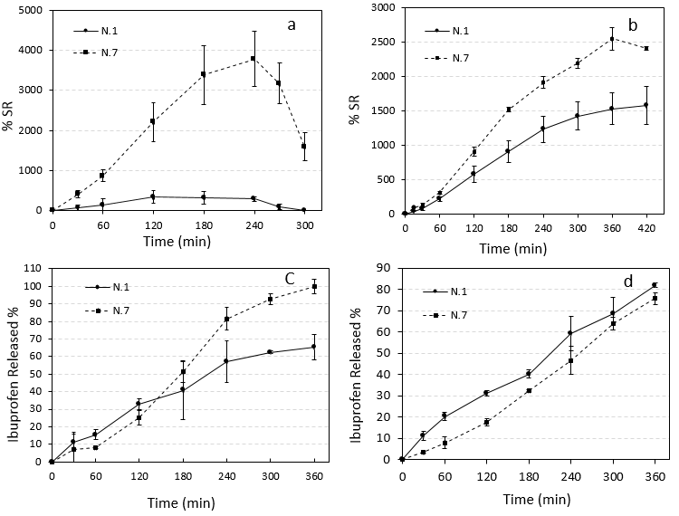
Fig. 5. Figures (a) and (b) represent the swelling profiles of CABs N1 and N7 in SIFp and SIFm respectively (n=3 ± SD). Figures (c) and (d) represent IBU release profiles from CABs N1 and CABs N7 in SIFp and SIFm respectively (n=3 ± SD).

3.7. Impact of NCL-Ca on the drug release in SIFs
Fig. 5 shows the cumulative release of IBU from CABs N1 and N7 in both SIFm (Fig. 5c) and SIFm (Fig. 5d). IBU release from CABs N1 in the SIFm was significantly faster than that from CABs N7 (Fig. 5d). However, there were no significant differences between the drug release profiles of both CABs N1 and N7 in SIFp during the first 3 hours of the dissolution test (P > 0.05) (Fig. 5c). Thereafter, drug release profile of CABs N7 became significantly faster than that of CABs N1 (P < 0.05) (Fig. 5c). Drug release from CABs is mainly controlled by swelling and/or drug diffusion through the swollen polysaccharide matrix (Siepmann & Siepmann, 2012). Beads degradation may also hasten drug release rate, particularly in late stages of the release. Swollen Alginate beads possess pores with approximately 5 to 200 nm diameters, which is definitely larger than the dimension of IBU molecules (0.5 × 1.2 × 0.8 nm) (Hillerstrom, van Stam & Andersson, 2009, Inger-Lill, Olav, Olav, Kjetill & Per Chr, 1977, Otterlei, Ostgaard, Skjak-Braek, Smidsrod, Soon-Shiong & Espevik, 1991, Tanaka, Matsumura & Veliky, 1984). Therefore, the release of IBU through alginate beads might not be controlled by diffusion rather than the rate of swelling process; thus, the degradation of beads. Beads swelling increases the diffusion pathway and this reduces the drug-concentration gradient and decreases the drug-release rate (Siepmann & Siepmann, 2012). In correspondence to bead swelling results (Fig. 5a and 5b), IBU release in SIFm from CABs N7 was slower than that of CABs N1 the least swollen bead (Fig. 5d). In contrast, using SIFp, IBU release from beads N7 increased dramatically after 3 h (Fig. 5c), the beginning of beads disintegration (Fig. 5a). Therefore, IBU release from CABs N7 in SIFp is suggested to be predominantly governed the erosion and disintegration of these beads after 3 h of incubation. On the other hand, the protective layer of the dicalcium phosphate precipitate formed on the surface of the CABs N1 slows down the drug release in SIFp during the same period of time. These results highlight the importance of the composition of SIFs for drug release studies. Phosphate buffer is mainly used in the SIFs thanks to its high buffering capacity. However, phosphate buffer is not bio-relevant and do not simulate the composition and the ionic strength of biological fluids (Alhnan, Kidia & Basit, 2011, Fadda, Merchant, Arafat & Basit, 2009). Therefore, and in correspondence with our results, alternative buffers, such as bicarbonate, maleate or acetate buffer, have been suggested for dissolution studies (Alhnan, Kidia & Basit, 2011, Boni, Brickl & Dressman, 2007, Fadda, Merchant, Arafat & Basit, 2009).

3.8. Impact of NCL-Ca on CABs mucoadhesiveness in SIFm
Fig. 6 shows the wash-off behaviour of CABs N1 and N7 performed in SIFm. The results show the percent of beads remained adhering to the intestine per time (min). The mucoadhesiveness was significantly different for both CABs. CABs N7 display a higher mucoadhesiveness with 48±6.9% of beads remained adherent on the mucosal tissue after 2 h of the wash-off test. On the other hand, only 6.6±4.6% of CABs N1 were still adhered on the mucosal tissue after the same period (Fig. 6).
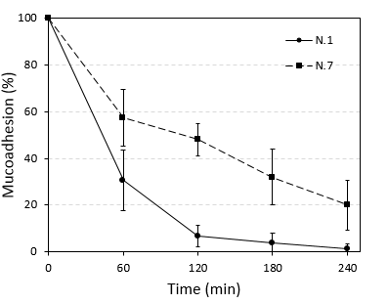
Fig.6. Mucoadhesion of CABs N1 and CABs N7 in SIFm (n=3 ± SD).
The mucoadhesiveness of alginate is mainly related to the ability of carboxylic groups to form hydrogen-bonds with oligosaccharide chains of mucins (Khutoryanskiy, 2011). Indeed, the difference in the mucoadhesion behaviour of CABs N1 and N7 might be explained by the difference in the Ca⁺² contents of these two formulations (Fig. 3a). It is well known that Ca⁺² decreases the viscosity of mucus and may collapse entirely the mucin gel (Forstner & Forstner, 1976, Lai, Wang, Wirtz & Hanes, 2009, Raynal, Hardingham, Sheehan & Thornton, 2003). Decreasing the mucus viscosity would have a direct and negative impact on the mucoadhesion properties of CABs as the mucus layer with lower viscosity promotes weaker retention ability and less available groups for interactions with alginate.

4. Conclusion
In this study, IBU-loaded CABs with the same degree of crosslinking and different amounts of NCL-Ca were prepared in order to investigate the influence of NCL-Ca on beads properties and the drug release profiles in SIFs. This study showed that the washing step, often neglected by researchers, had a significant impact on the amount NCL-Ca retained by CABs. The washing process in term of number or duration significantly influenced the amount of NCL-Ca retained by beads; hence the beads properties such as EE, mucoadhesiveness, swelling and drug release in SIFs. These results highlight the importance of washing step and the amount of NCL-Ca when developing calcium alginate-based drug delivery systems. This study showed also that the composition of the SIFs is of great significance in order to perform reliable and consistent swelling and release studies.

References
M. A. Alhnan, E. Kidia, &A. W. Basit. (2011). Spray-drying enteric polymers from aqueous solutions: a novel, economic, and environmentally friendly approach to produce pH-responsive microparticles. Eur J Pharm Biopharm, 79(2), 432-439.
S. Alipour, H. Montaseri, &M. Tafaghodi. (2010). Preparation and characterization of biodegradable paclitaxel loaded alginate microparticles for pulmonary delivery. Colloids and Surfaces B: Biointerfaces, 81(2), 521-529.
C. Alvarez-Lorenzo, B. Blanco-Fernandez, A. M. Puga, &A. Concheiro. (2013). Crosslinked ionic polysaccharides for stimuli-sensitive drug delivery. Adv Drug Deliv Rev, 65(9), 1148-1171.
A. Assifaoui, O. Chambin, &P. Cayot. (2011). Drug release from calcium and zinc pectinate beads: Impact of dissolution medium composition. Carbohydrate Polymers, 85(2), 388-393.
S. Azarnia, B. H. Lee, N. Robert, &C. P. Champagne. (2008). Microencapsulation of a recombinant aminopeptidase (PepN) from Lactobacillus rhamnosus S93 in chitosan-coated alginate beads. J Microencapsul, 25(1), 46-58.
M. Barzegar-Jalali, J. Hanaee, Y. Omidi, S. Ghanbarzadeh, S. Ziaee, R. Bairami-Atashgah, &K. Adibkia. (2013). Preparation and evaluation of sustained release calcium alginate beads and matrix tablets of acetazolamide. Drug Res (Stuttg), 63(2), 60-64.
J. E. Boni, R. S. Brickl, &J. Dressman. (2007). Is bicarbonate buffer suitable as a dissolution medium? J Pharm Pharmacol, 59(10), 1375-1382.
S. Bourgeois, M. Gernet, D. Pradeau, A. Andremont, &E. Fattal. (2006). Evaluation of critical formulation parameters influencing the bioactivity of beta-lactamases entrapped in pectin beads. International Journal of Pharmaceutics, 324(1), 2-9.
B. H. Chueh, Y. Zheng, Y. S. Torisawa, A. Y. Hsiao, C. Ge, S. Hsiong, N. Huebsch, R. Franceschi, D. J. Mooney, &S. Takayama. (2010). Patterning alginate hydrogels using light-directed release of caged calcium in a microfluidic device. Biomed Microdevices, 12(1), 145-151.
H. Daemi, &M. Barikani. (2012). Synthesis and characterization of calcium alginate nanoparticles, sodium homopolymannuronate salt and its calcium nanoparticles. Scientia Iranica, 19(6), 2023-2028.
I. Donati, S. Holtan, Y. A. Morch, M. Borgogna, M. Dentini, &G. Skjak-Braek. (2005). New hypothesis on the role of alternating sequences in calcium-alginate gels. Biomacromolecules, 6(2), 1031-1040.
H. M. Fadda, H. A. Merchant, B. T. Arafat, &A. W. Basit. (2009). Physiological bicarbonate buffers: stabilisation and use as dissolution media for modified release systems. Int J Pharm, 382(1-2), 56-60.
M. Fathy, S. M. Safwat, S. M. el-Shanawany, S. Shawky Tous, &M. Otagiri. (1998). Preparation and evaluation of beads made of different calcium alginate compositions for oral sustained release of tiaramide. Pharm Dev Technol, 3(3), 355-364.
J. F. Forstner, &G. G. Forstner. (1976). Effects of Calcium on Intestinal Mucin: Implications for Cystic Fibrosis. Pediatr Res, 10(6), 609-613.
M. George, &T. E. Abraham. (2006). Polyionic hydrocolloids for the intestinal delivery of protein drugs: alginate and chitosan--a review. J Control Release, 114(1), 1-14.
T. K. Giri, D. Thakur, A. Alexander, Ajazuddin, H. Badwaik, &D. K. Tripathi. (2012). Alginate based hydrogel as a potential biopolymeric carrier for drug delivery and cell delivery systems: present status and applications. Curr Drug Deliv, 9(6), 539-555.
C. J. Gray, &J. Dowsett. (1988). Retention of insulin in alginate gel beads. Biotechnol Bioeng, 31(6), 607-612.
P. W. Heng, L. W. Chan, &T. W. Wong. (2003). Formation of alginate microspheres produced using emulsification technique. J Microencapsul, 20(3), 401-413.
A. Hillerstrom, J. van Stam, &M. Andersson. (2009). Ibuprofen loading into mesostructured silica using liquid carbon dioxide as a solvent. Green Chemistry, 11(5), 662-667.
A. Inger-Lill, S. Olav, S. D. Olav, O. Kjetill, &H. Per Chr. (1977). Some Biological Functions of Matrix Components in Benthic Algae in Relation to Their Chemistry and the Composition of Seawater. Cellulose Chemistry and Technology (Vol. 48, pp. 361-381): AMERICAN CHEMICAL SOCIETY.
C. Iskenderoglu, F. Acarturk, D. Erdogan, &Y. Bardakci. (2013). In vitro and in vivo investigation of low molecular weight heparin-alginate beads for oral administration. J Drug Target, 21(4), 389-406.
S. Jabeen, O. A. Chat, M. Maswal, U. Ashraf, G. M. Rather, &A. A. Dar. (2015). Hydrogels of sodium alginate in cationic surfactants: Surfactant dependent modulation of encapsulation/release toward Ibuprofen. Carbohydrate Polymers, 133, 144-153.
E. Jamstorp, A. Bodin, P. Gatenholm, A. Jeppsson, &M. Stromme. (2010). Release of antithrombotic drugs from alginate gel beads. Curr Drug Deliv, 7(4), 297-302.
M. Khoder, N. Tsapis, V. Domergue-Dupont, C. Gueutin, &E. Fattal. (2010). Removal of residual colonic ciprofloxacin in the rat by activated charcoal entrapped within zinc-pectinate beads. Eur J Pharm Sci, 41(2), 281-288.
M. Khoder, N. Tsapis, H. Huguet, M. Besnard, C. Gueutin, &E. Fattal. (2009). Removal of ciprofloxacin in simulated digestive media by activated charcoal entrapped within zinc-pectinate beads. Int J Pharm, 379(2), 251-259.
V. V. Khutoryanskiy. (2011). Advances in mucoadhesion and mucoadhesive polymers. Macromol Biosci, 11(6), 748-764.
A. Kikuchi, M. Kawabuchi, A. Watanabe, M. Sugihara, Y. Sakurai, &T. Okano. (1999). Effect of Ca2+-alginate gel dissolution on release of dextran with different molecular weights. J Control Release, 58(1), 21-28.
W.-T. Kim, H. Chung, I.-S. Shin, K. L. Yam, &D. Chung. (2008). Characterization of calcium alginate and chitosan-treated calcium alginate gel beads entrapping allyl isothiocyanate. Carbohydrate Polymers, 71(4), 566-573.
S. K. Lai, Y. Y. Wang, D. Wirtz, &J. Hanes. (2009). Micro- and macrorheology of mucus. Adv Drug Deliv Rev, 61(2), 86-100.
B.-J. Lee, &G.-H. Min. (1996). Oral controlled release of melatonin using polymer-reinforced and coated alginate beads. International Journal of Pharmaceutics, 144(1), 37-46.
C.-M. Lehr, J. A. Bouwstra, E. H. Schacht, &H. E. Junginger. (1992). In vitro evaluation of mucoadhesive properties of chitosan and some other natural polymers. International Journal of Pharmaceutics, 78(1), 43-48.
F. Lindstrom, &H. Diehl. (1960). Indicator for the Titration of Calcium Plus Magnesium with (Ethylenedinitrilo)tetraacetate. Analytical Chemistry, 32(9), 1123-1127.
Y. A. Morch, I. Donati, B. L. Strand, &G. Skjak-Braek. (2006). Effect of Ca2+, Ba2+, and Sr2+ on alginate microbeads. Biomacromolecules, 7(5), 1471-1480.
M. Otterlei, K. Ostgaard, G. Skjak-Braek, O. Smidsrod, P. Soon-Shiong, &T. Espevik. (1991). Induction of cytokine production from human monocytes stimulated with alginate. J Immunother (1991), 10(4), 286-291.
S. K. Papageorgiou, F. K. Katsaros, E. P. Kouvelos, J. W. Nolan, H. Le Deit, &N. K. Kanellopoulos. (2006). Heavy metal sorption by calcium alginate beads from Laminaria digitata. Journal of Hazardous Materials, 137(3), 1765-1772.
S. K. Prajapati, P. Tripathi, U. Ubaidulla, &V. Anand. (2008). Design and Development of Gliclazide Mucoadhesive Microcapsules: In Vitro and In Vivo Evaluation. AAPS PharmSciTech, 9(1), 224-230.
P. S. Rajinikanth, C. Sankar, &B. Mishra. (2003). Sodium alginate microspheres of metoprolol tartrate for intranasal systemic delivery: development and evaluation. Drug Deliv, 10(1), 21-28.
B. D. Raynal, T. E. Hardingham, J. K. Sheehan, &D. J. Thornton. (2003). Calcium-dependent protein interactions in MUC5B provide reversible cross-links in salivary mucus. J Biol Chem, 278(31), 28703-28710.
K. Schutz, F. Despang, A. Lode, &M. Gelinsky. (2014). Cell-laden biphasic scaffolds with anisotropic structure for the regeneration of osteochondral tissue. J Tissue Eng Regen Med.
C. M. Setty, S. S. Sahoo, &B. Sa. (2005). Alginate-coated alginate-polyethyleneimine beads for prolonged release of furosemide in simulated intestinal fluid. Drug Dev Ind Pharm, 31(4-5), 435-446.
J. Siepmann, &F. Siepmann. (2012). Swelling Controlled Drug Delivery Systems. In J. Siepmann, R. A. Siegel & M. J. Rathbone (Eds.). Fundamentals and Applications of Controlled Release Drug Delivery (pp. 153-170): Springer US.
P. K. Singh, P. K. Deol, &I. P. Kaur. (2012). Entrapment of Lactobacillus acidophilus into alginate beads for the effective treatment of cold restraint stress induced gastric ulcer. Food Funct, 3(1), 83-90.
A. Sosnik. (2014). Alginate Particles as Platform for Drug Delivery by the Oral Route: State-of-the-Art. ISRN Pharm, 2014, 926157.
P. Sriamornsak, &R. A. Kennedy. (2006). Development of polysaccharide gel-coated pellets for oral administration. 2. Calcium alginate. Eur J Pharm Sci, 29(2), 139-147.
P. Sriamornsak, &R. A. Kennedy. (2008). Swelling and diffusion studies of calcium polysaccharide gels intended for film coating. Int J Pharm, 358(1-2), 205-213.
P. Sriamornsak, N. Thirawong, &K. Korkerd. (2007). Swelling, erosion and release behavior of alginate-based matrix tablets. Eur J Pharm Biopharm, 66(3), 435-450.
H. Tanaka, M. Matsumura, &I. A. Veliky. (1984). Diffusion characteristics of substrates in Ca-alginate gel beads. Biotechnol Bioeng, 26(1), 53-58.
A. C. Tas. (2009). Monetite (CaHPO4) Synthesis in Ethanol at Room Temperature. Journal of the American Ceramic Society, 92(12), 2907-2912.
K. Tateshita, S. Sugawara, T. Imai, &M. Otagiri. (1993). Preparation and evaluation of a controlled-release formulation of nifedipine using alginate gel beads. Biol Pharm Bull, 16(4), 420-424.
H. H. Tonnesen, &J. Karlsen. (2002). Alginate in drug delivery systems. Drug Dev Ind Pharm, 28(6), 621-630.
D. Velasco, C. B. Danoux, J. A. Redondo, C. Elvira, J. San Román, P. S. Wray, &S. G. Kazarian. (2011). pH-sensitive polymer hydrogels derived from morpholine to prevent the crystallization of ibuprofen. Journal of Controlled Release, 149(2), 140-145.
F. Xu, L. Xu, Q. Wang, Z. Ye, Y. Zhou, &W. S. Tan. (2014). 3D Dynamic Culture of Rabbit Articular Chondrocytes Encapsulated in Alginate Gel Beads Using Spinner Flasks for Cartilage Tissue Regeneration. Biomed Res Int, 2014, 539789.
Y.-T. Yang, A. J. Di Pasqua, W. He, T. Tsai, K. Sueda, Y. Zhang, &M. Jay. (2013). Preparation of alginate beads containing a prodrug of diethylenetriaminepentaacetic acid. Carbohydrate Polymers, 92(2), 1915-1920.

